### Tableau Lecture 2: Basic Charts and Operations

### **Agenda**

* Data Connection in Tableau
* Aggregation on Dimensions and Measures
* Basic Charts
* Cleaning and Formatting data for analysis
* Introduction to Summer Olympics dataset

### **What is Visual Analytics?**

* It is the use of sophisticated tools and processes to analyze datasets using visual representations of the data.

#### **Why is it important?**

* Users get actionable insights which in turn help organizations make better, data-driven decisions.
* Allows users without data science skills or experience to combine, manipulate, and explore large, dynamic, multi-dimensional, and multi-sourced datasets.

**Difference between Visual Analytics and Data Visualization**

| Data Visualization | Visual Analytics |
| --- | --- |
| Graphical/Visual depiction of data to help people better understand the patterns, relationships, trends, and other meaningful insights in datasets. | The use of an analytics program to perform advanced analysis of complex datasets allowing users to explore and interact with dynamic visualizations. |

## **Tableau Live and Extract Connections**

Live and Extracts are two ways you can make the data connection to the Tableau.

| Live connection | Extract connection |
| --- | --- |
| Live allows you real-time data. | Extract is kind of a batch which needs to be refreshed from time to time to get the updated data. |
| Whatever changes are done at the data source will be directly available to Tableau Desktop (professional). | Any changes made in the data source won’t reflect in the report immediately. It will be reflected when the extract is refreshed. |

**Note:**

* Tableau Public only supports extract connections.
* Tableau Desktop (professional) supports both live and extract connections.

## **Types of Aggregation on measures and dimensions :**

* We can add aggregation to dimension and measures in Tableau.
* [Types of aggregation for measures](https://help.tableau.com/current/pro/desktop/en-us/calculations_aggregation.htm#AggFuncs)
* We can convert a dimension to a measure and perform aggregation on it.
* [Types of aggregation for dimension](https://help.tableau.com/current/pro/desktop/en-us/calculations_aggregation.htm#:~:text=its%20context%20menu%3A-,Aggregating%20Dimensions,-You%20can%20aggregate)
* If you want to remove the default aggregation for fields in the view than click on analysis and clear the aggregate measure option.

#### **Business problem 1:**

* Determine the average sales value of each category.
  + Drag Category to Columns
  + Drag Sales to Rows
  + Change aggregation of Sales from Sum to Average

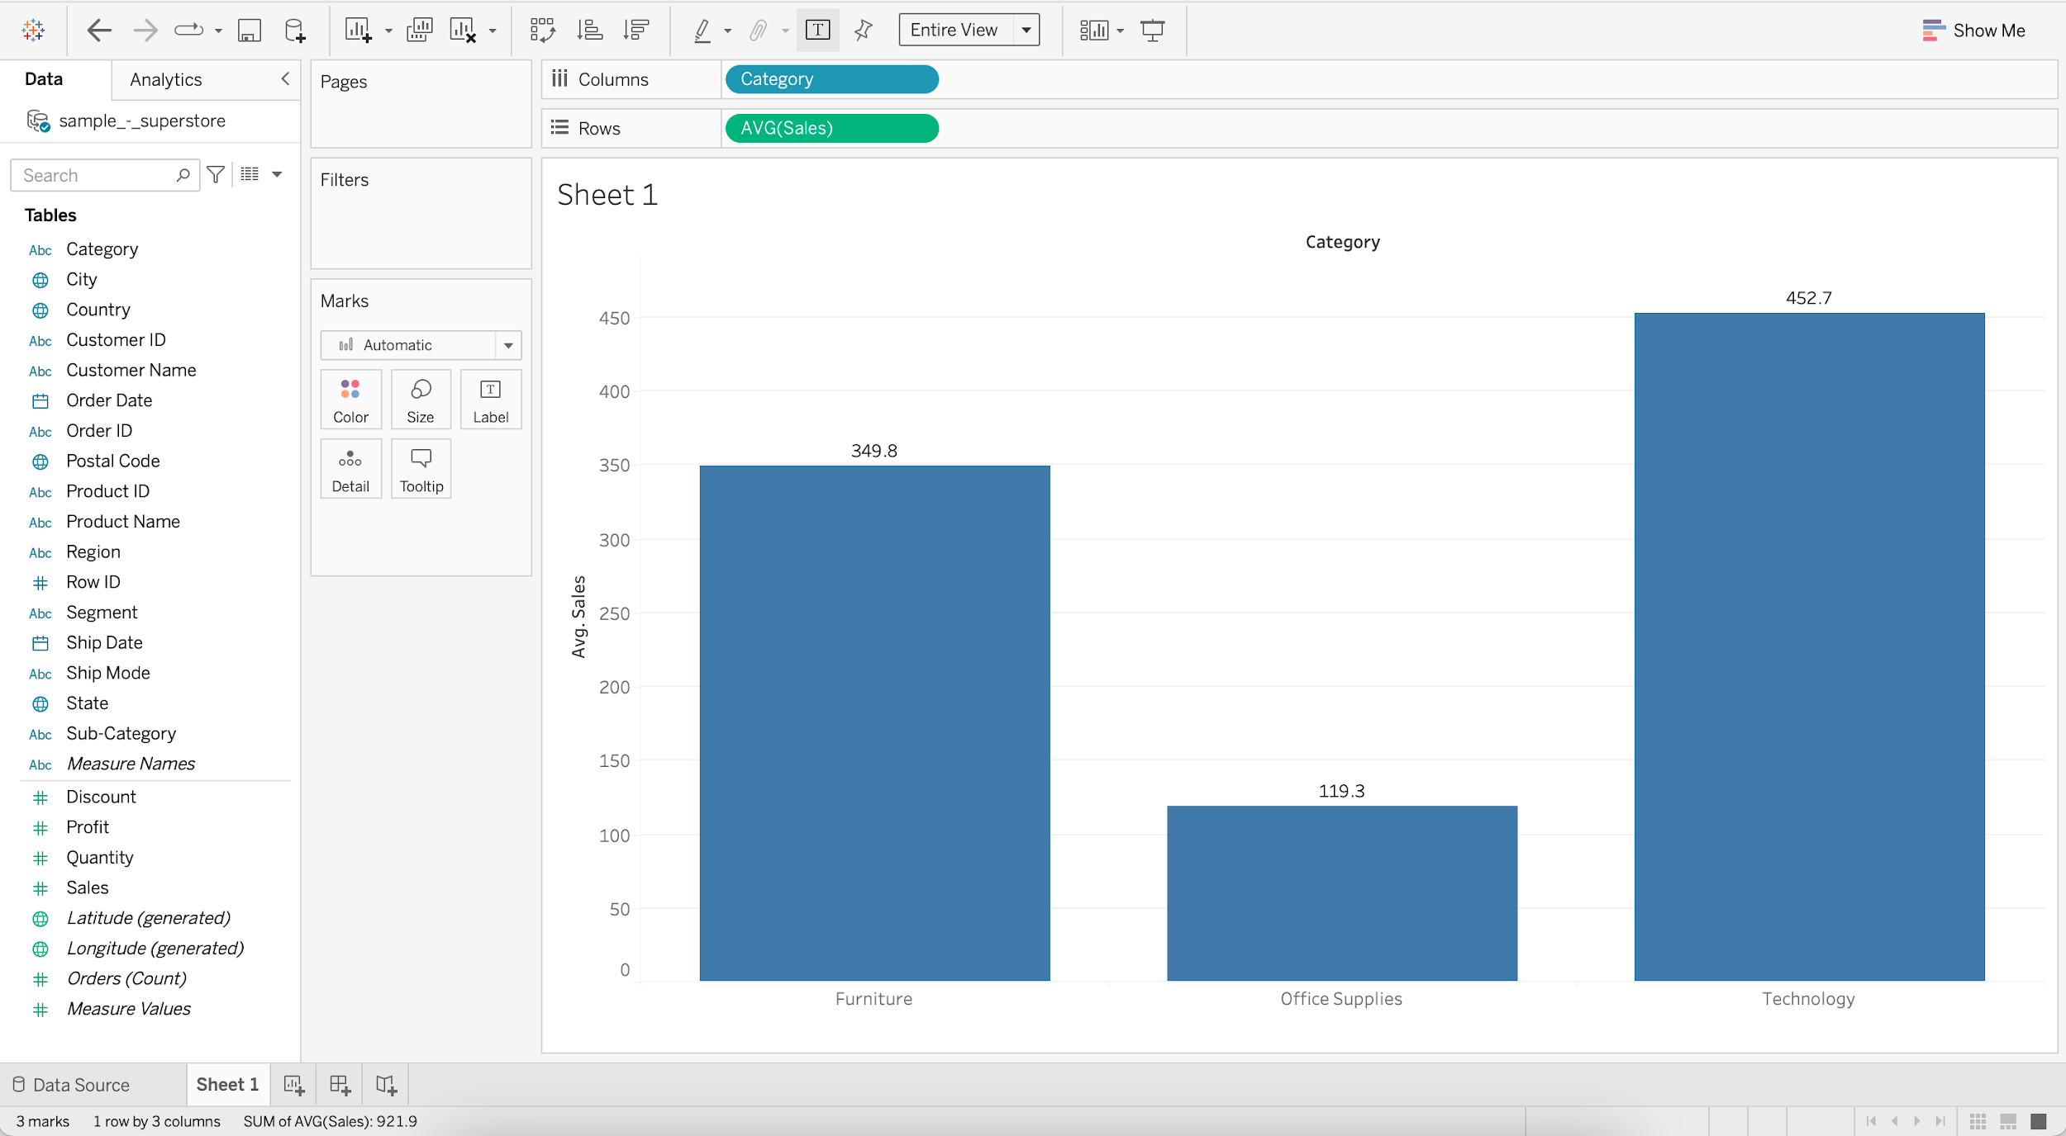

#### We can demonstrate color marks card shelf.

* If we drag Sales onto the color marks card shelf it’ll assign a single color with different shades of that color.

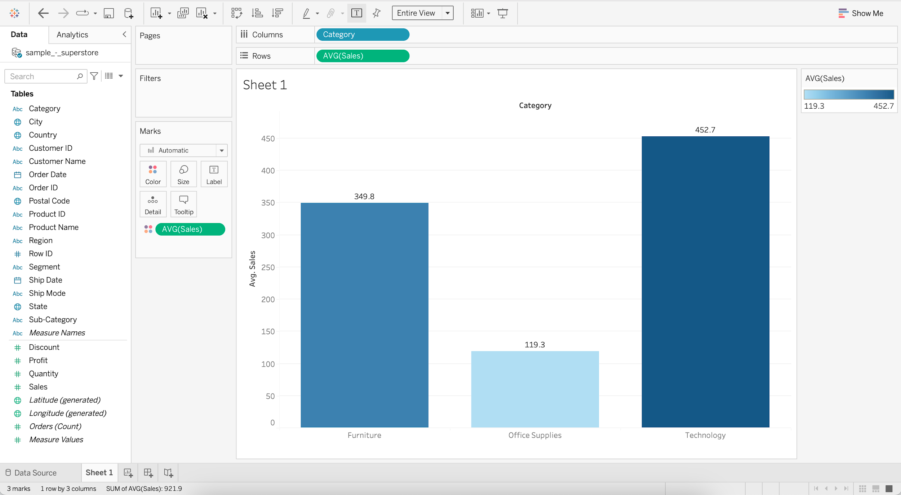

* If we drag the Category to the color marks card shelf we’ll get different color for each category.

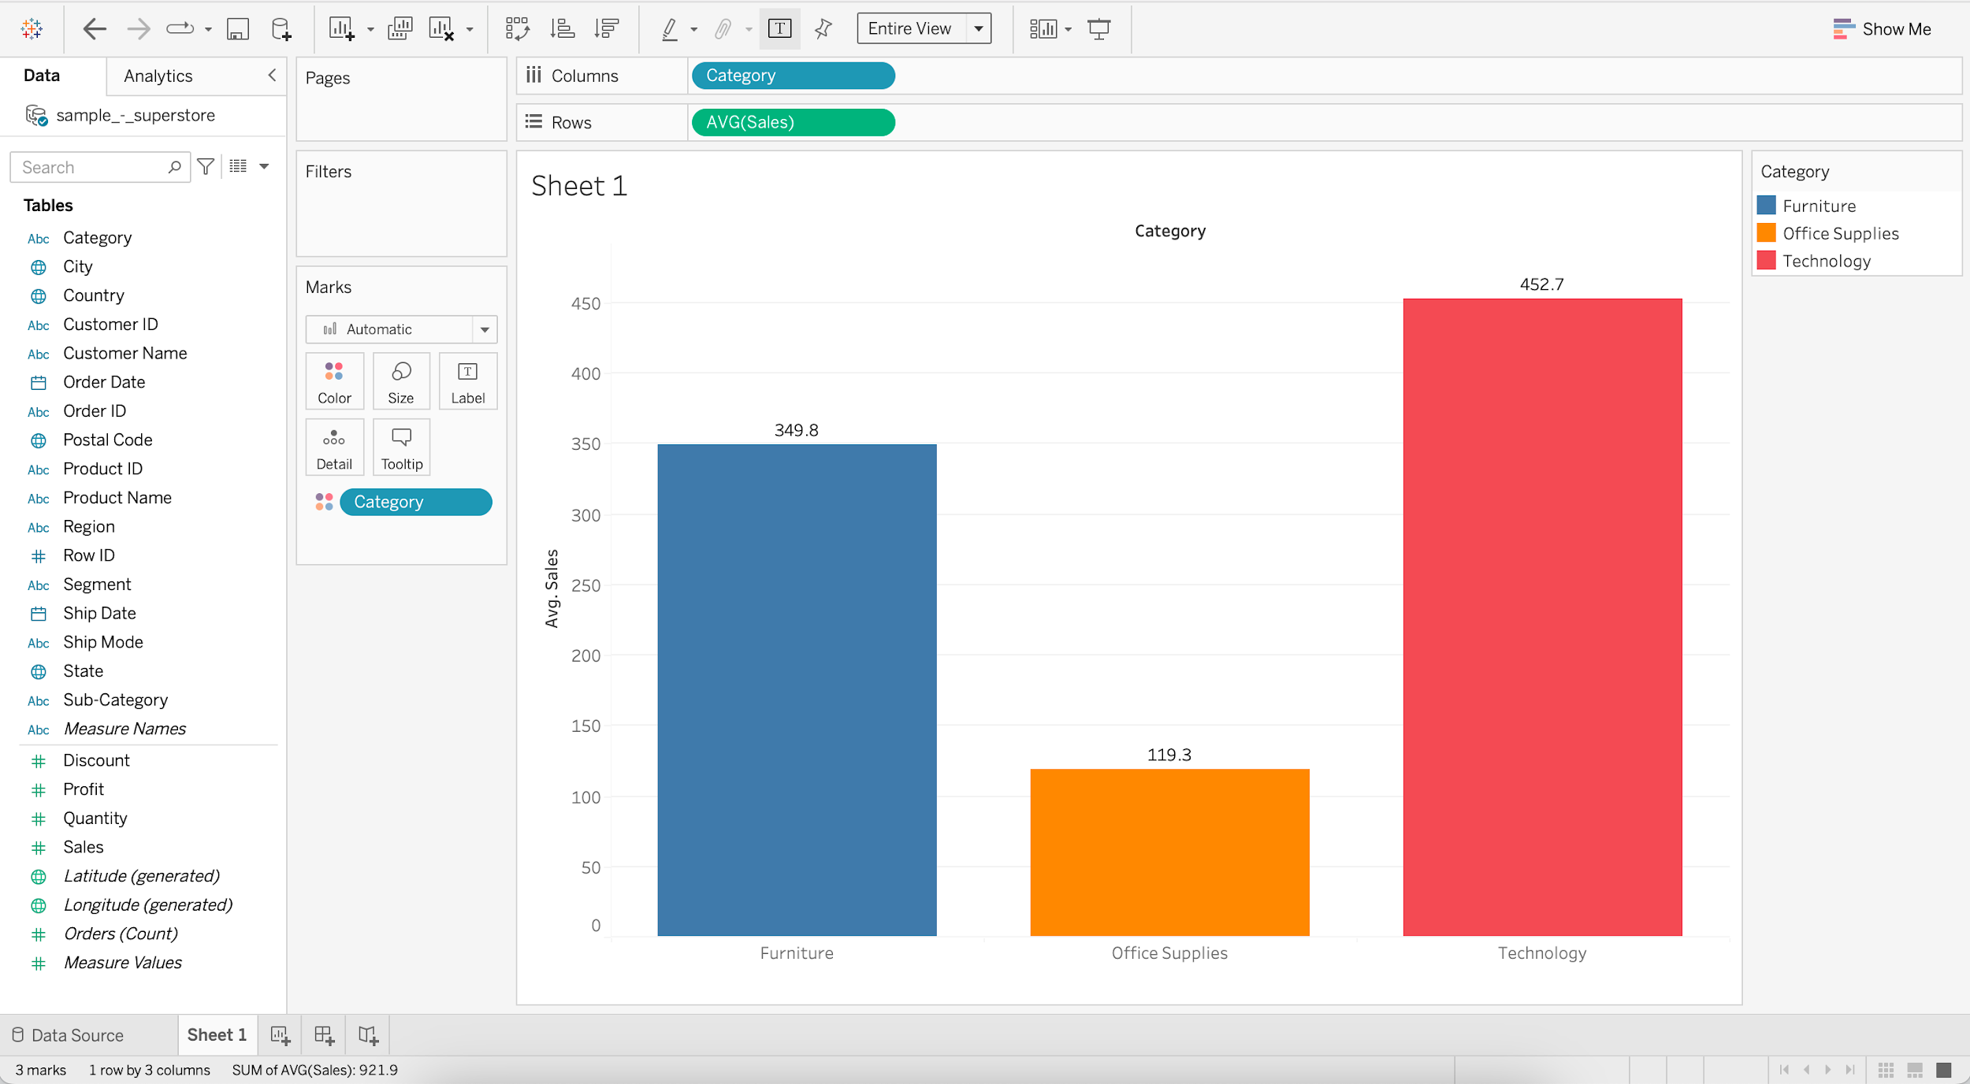

#### **Business problem 2:**

* Determine total number of products within each Category.
  + Drag Category to Columns
  + Drag Product ID to Rows
  + Change aggregation of Product ID to Count Distinct

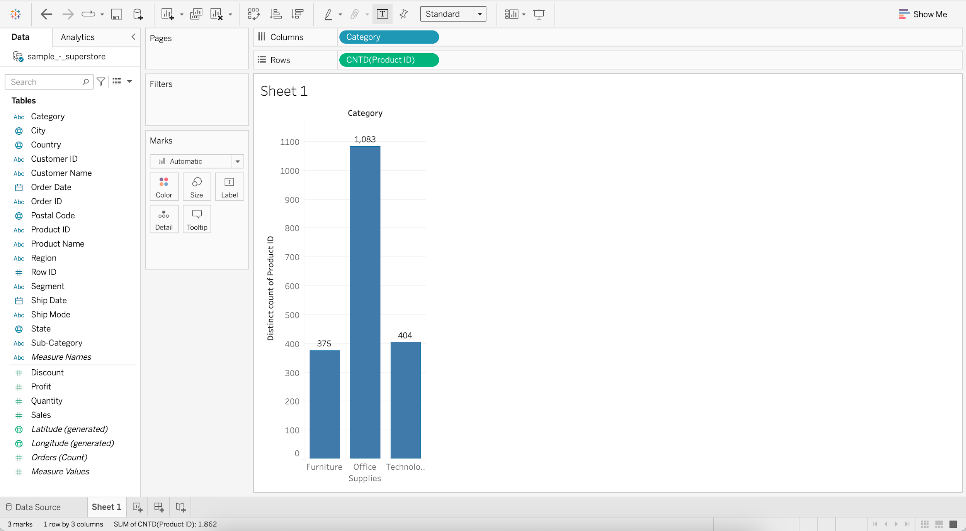

#### **Line chart**

* They connect individual data points in a view. They provide a simple way to visualize a sequence of values and are useful when you want to see trends over time.
* **Discrete line chart**
  + **Business problem 3** : Find product category that has highest sales for most of the years.
    - Drag Order Date to Columns
    - Drag Sales to Rows
    - Add Category to Color

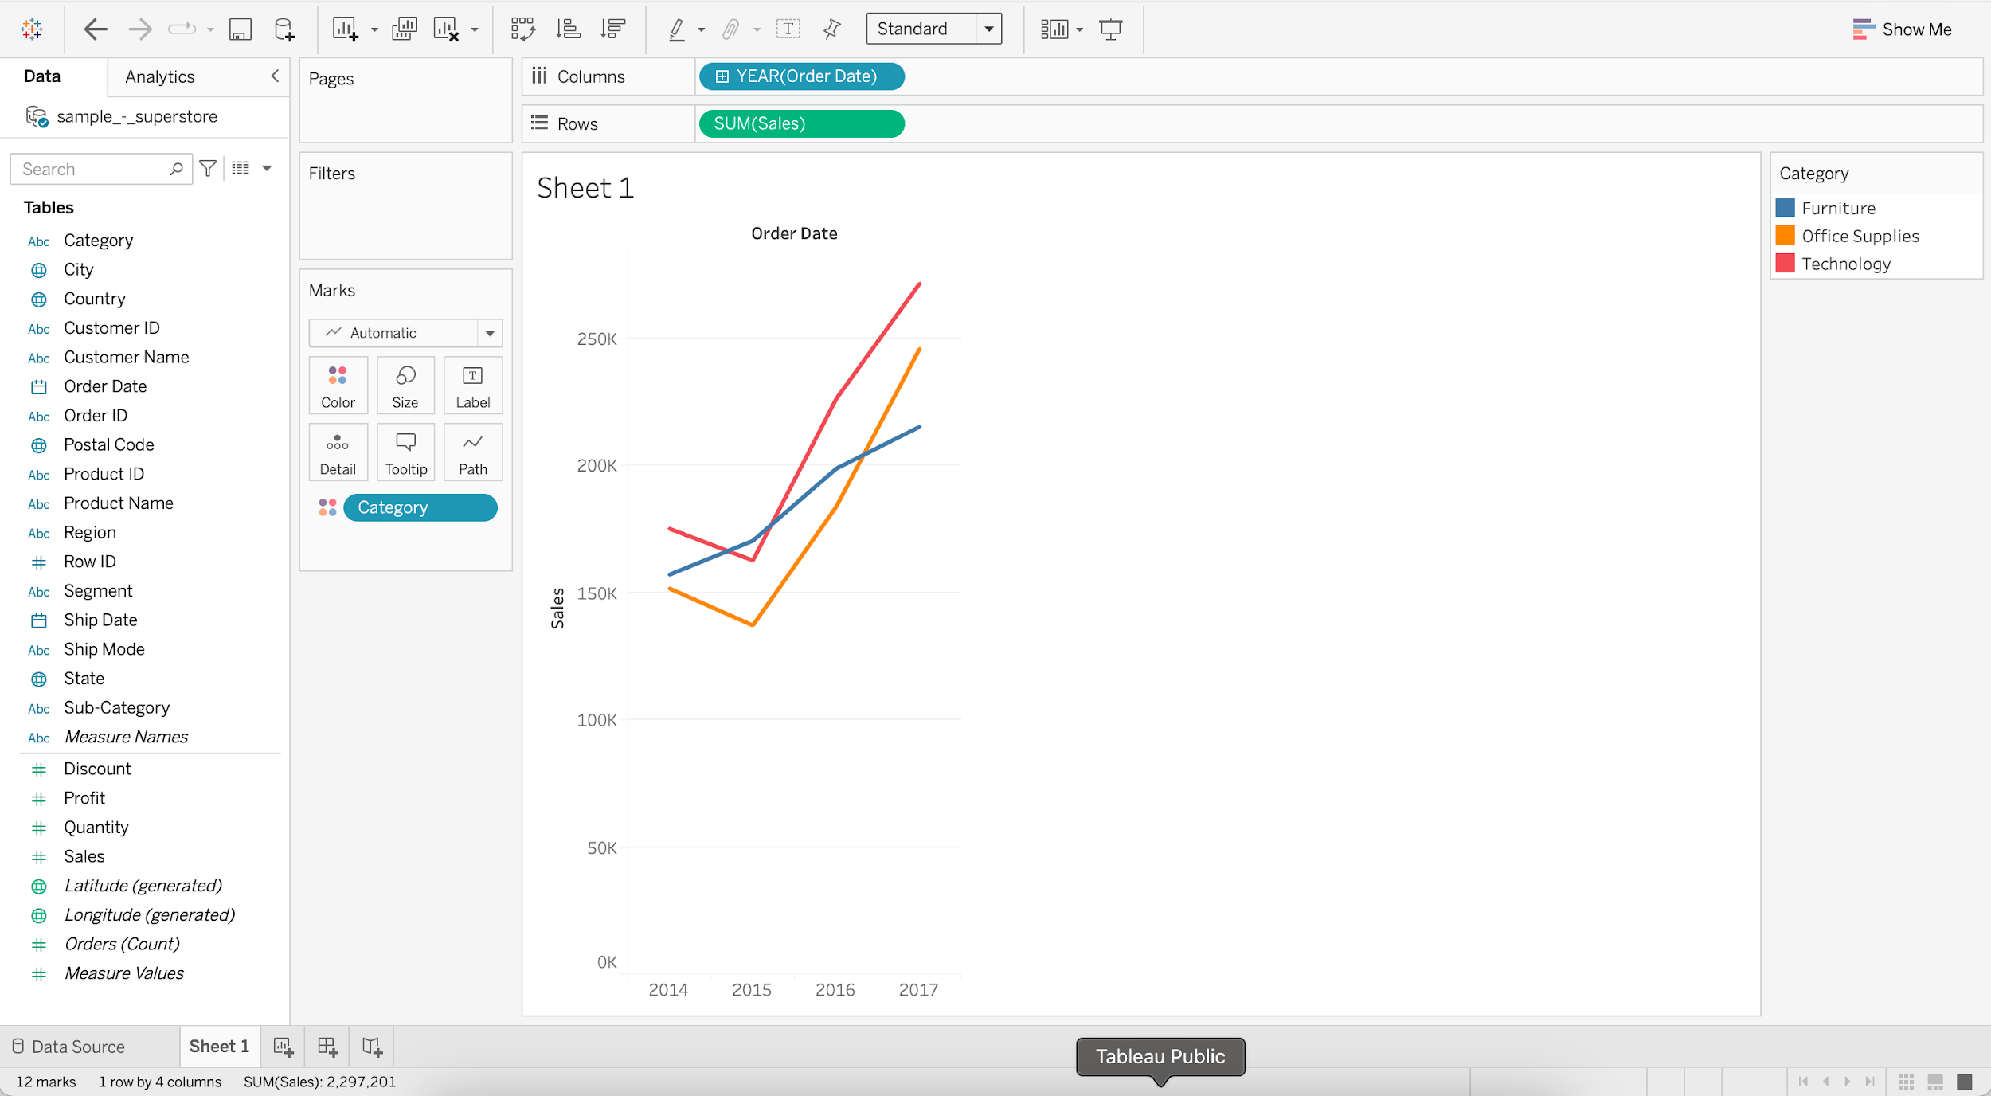

* **Continuous line chart**
  + **Business problem 4** : Find the year and month that had the highest and lowest sales.
    - Drag Order Date to Columns
    - Drag Sales to Rows
    - Switch from YEAR (E.g. 2015) to MONTH (E.g. May 2015)

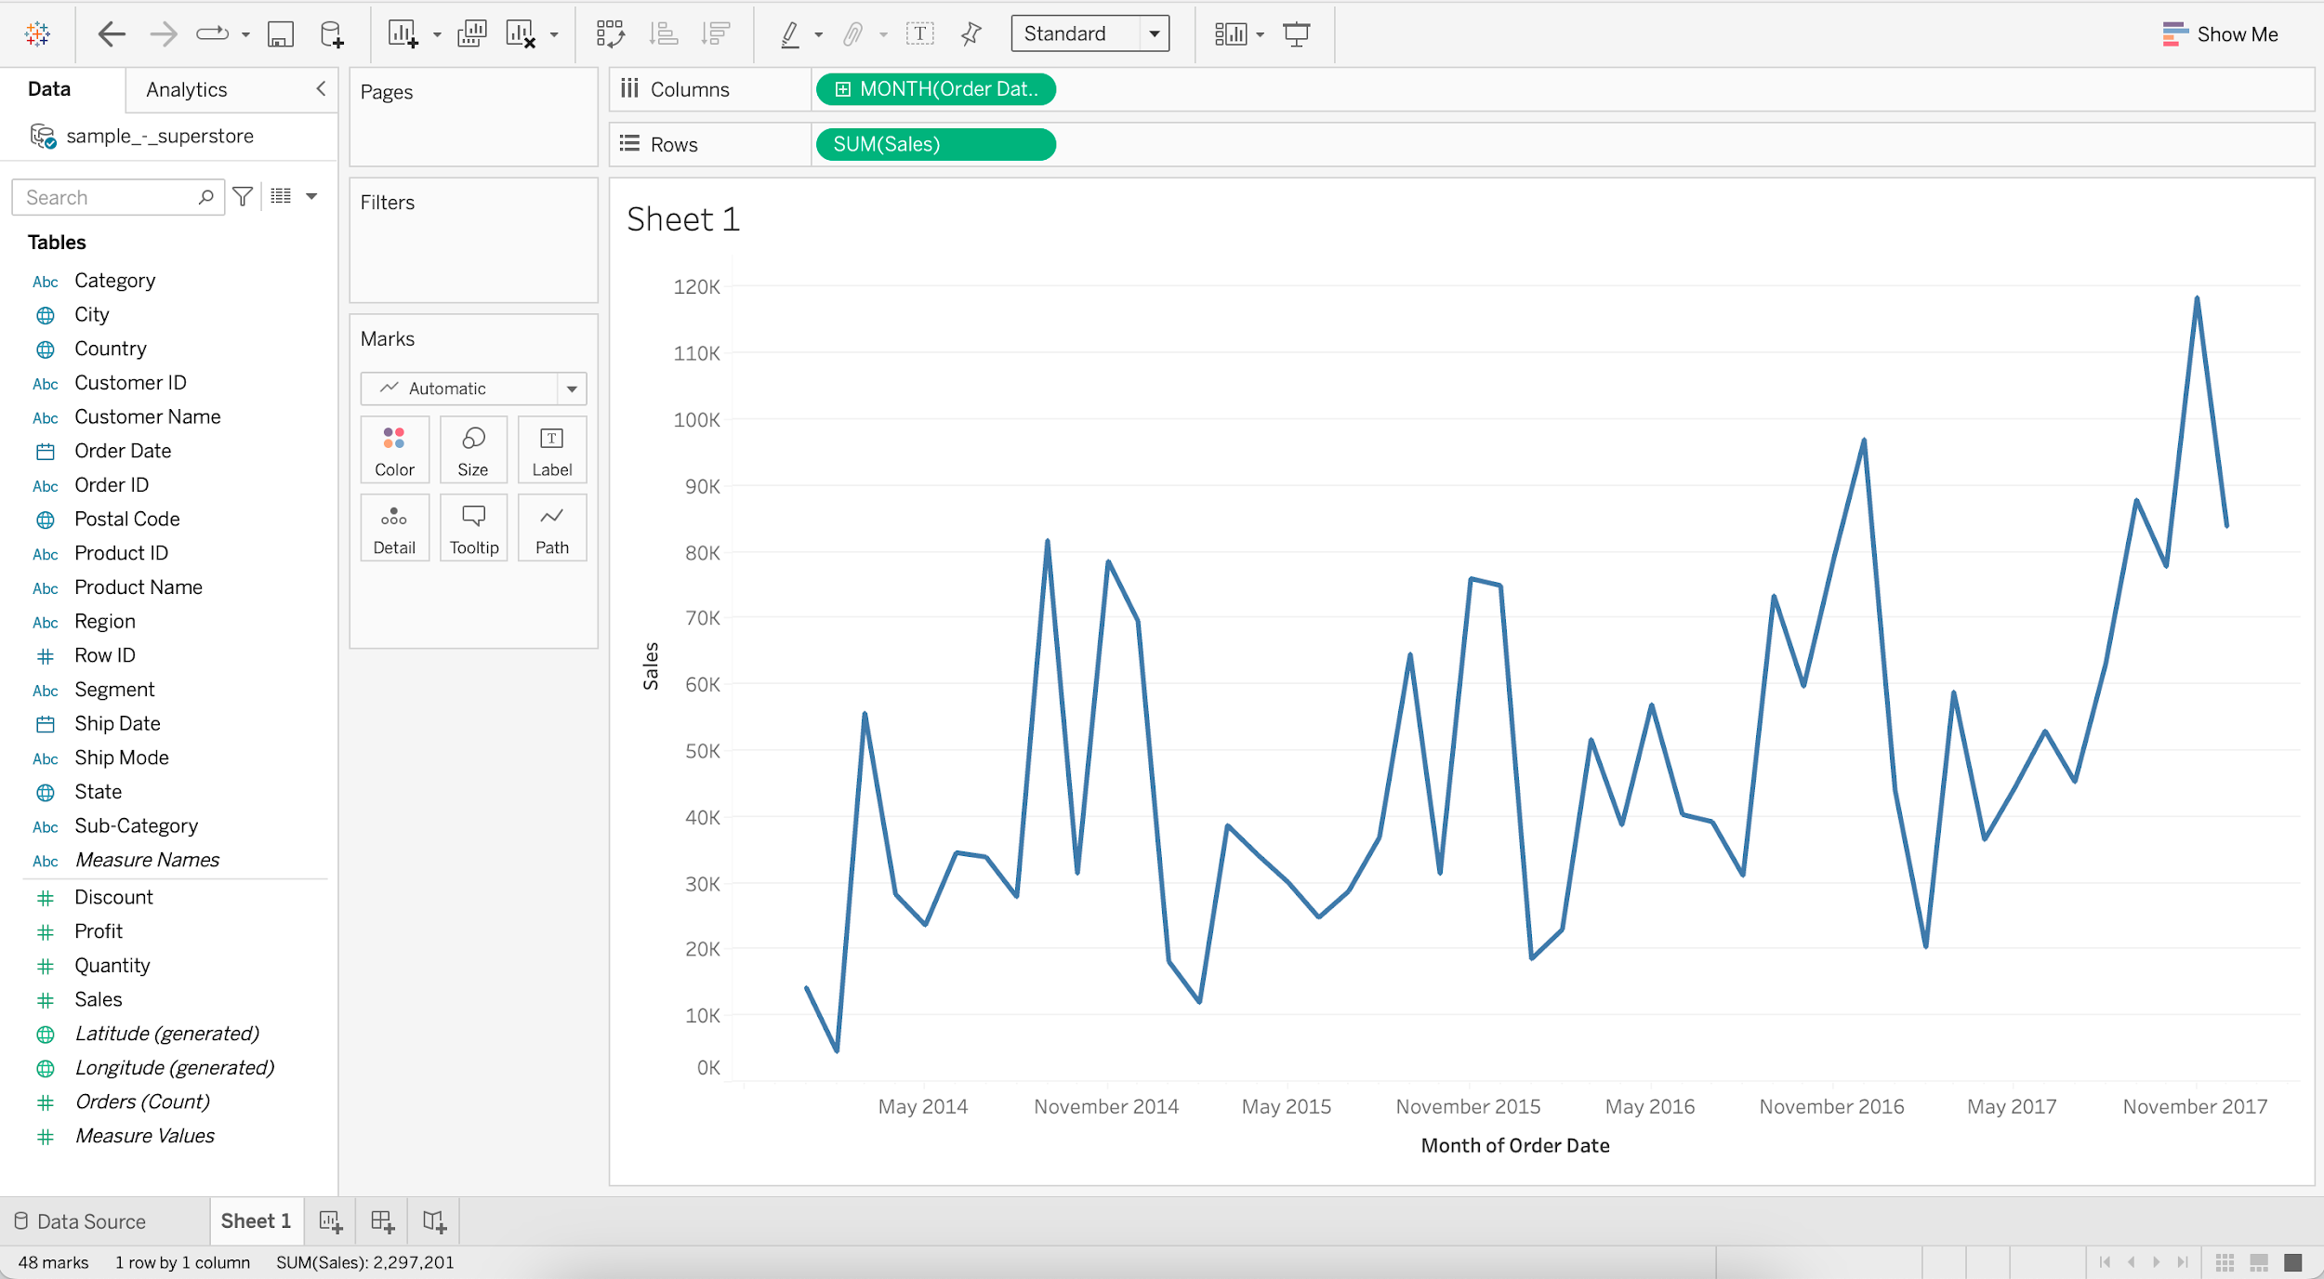

* + Annotating the Line chart with min and max Sales.
    - Add Sales to Label
    - Add Order Date to Label
    - Click on Label and choose “Marks to Label” as Min/Max

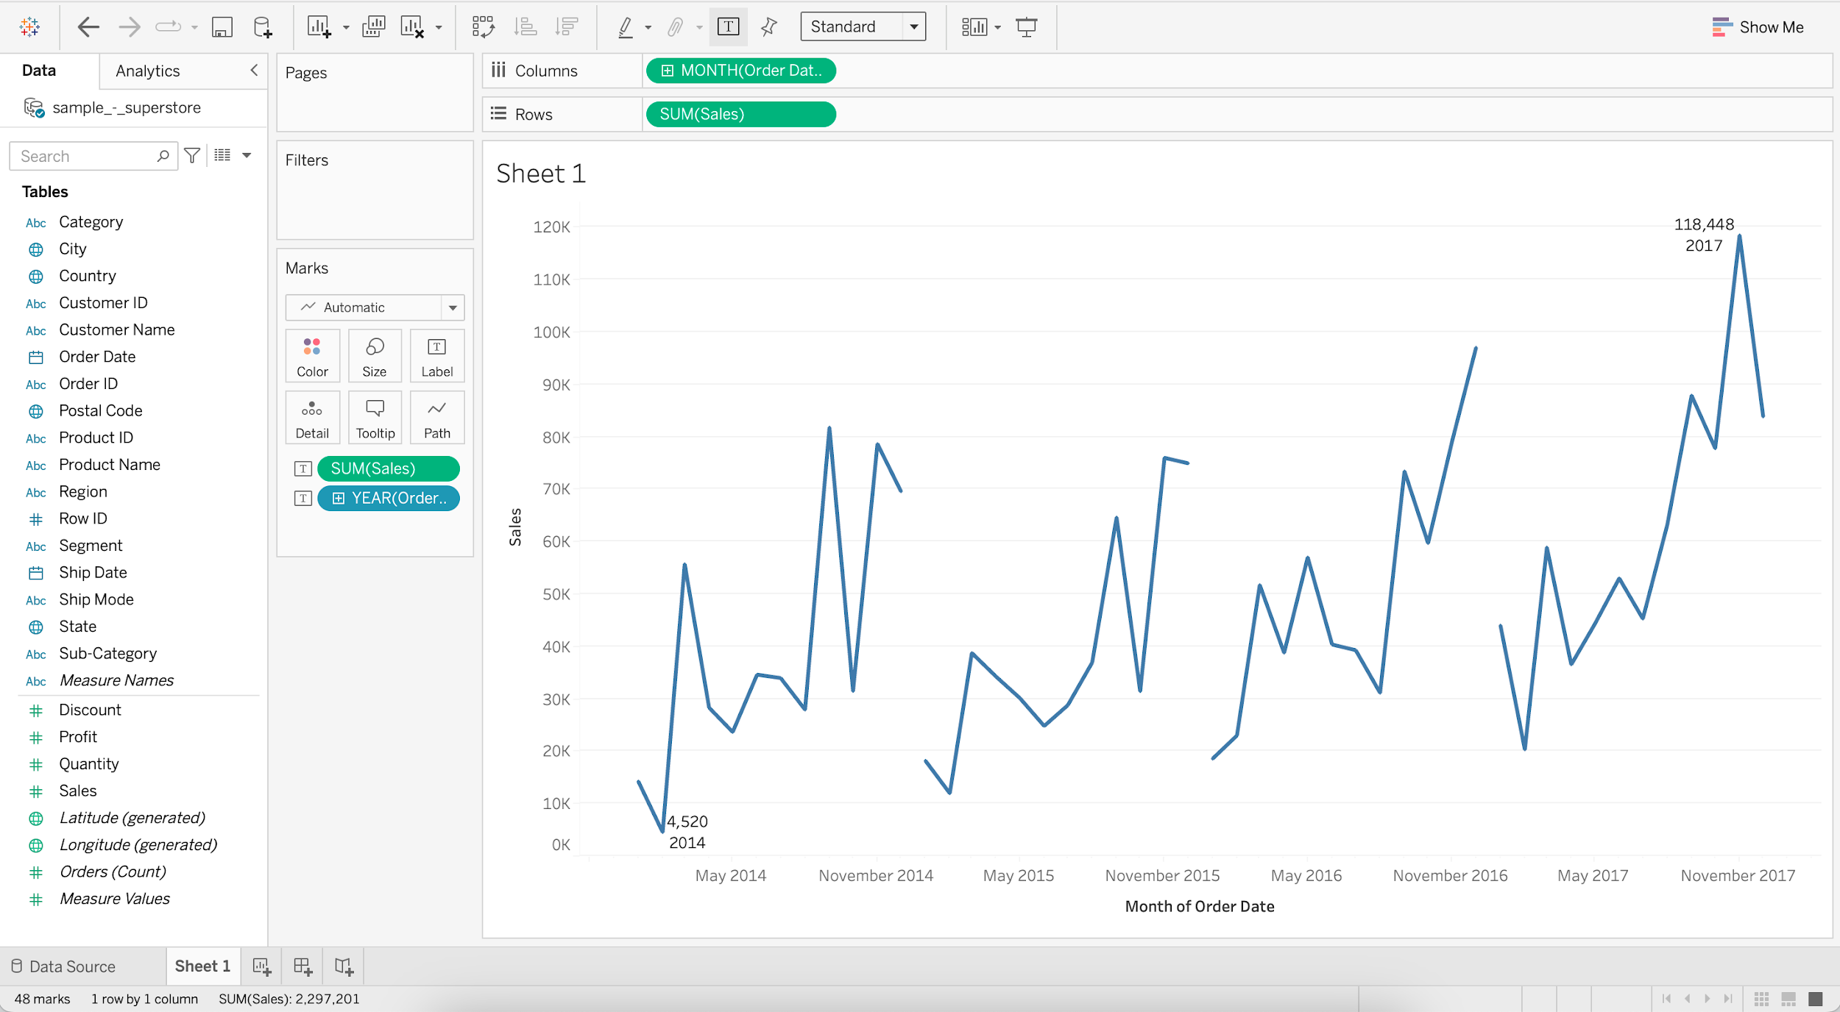

#### **Bar chart**

* It is a chart with rectangular bars where lengths and heights are proportional to the value that they represent.
* **Horizontal bar chart**
  + It is a bar graph that represents data horizontally, dimensions are present on the vertical axis and data values on the horizontal axis.
  + **Business problem 5** : Find sales and profit by region for the year 2017.
    - Drag Sales to Columns
    - Drag Region to Rows

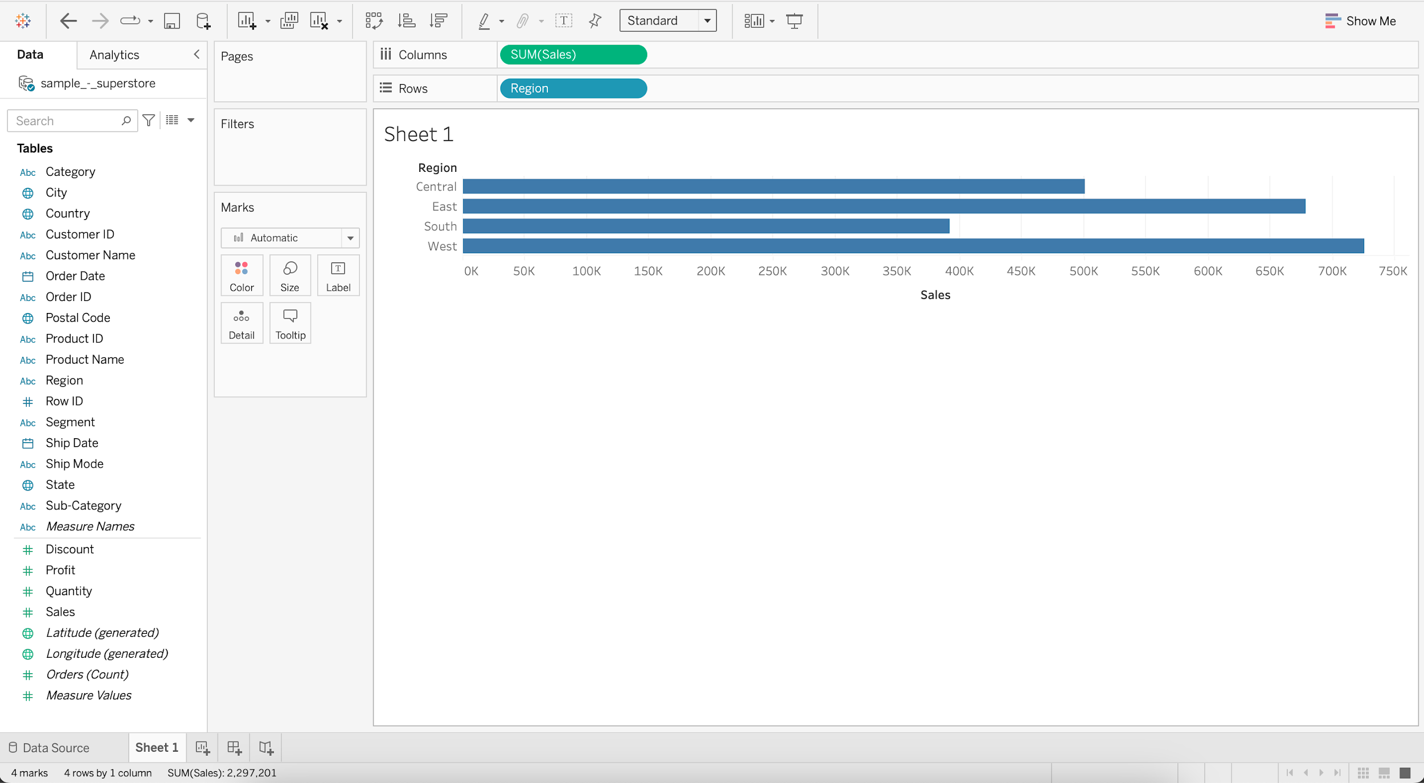

* + - Put Order Date into Filters
    - Select Years and press next
    - Select 2017 and press OK

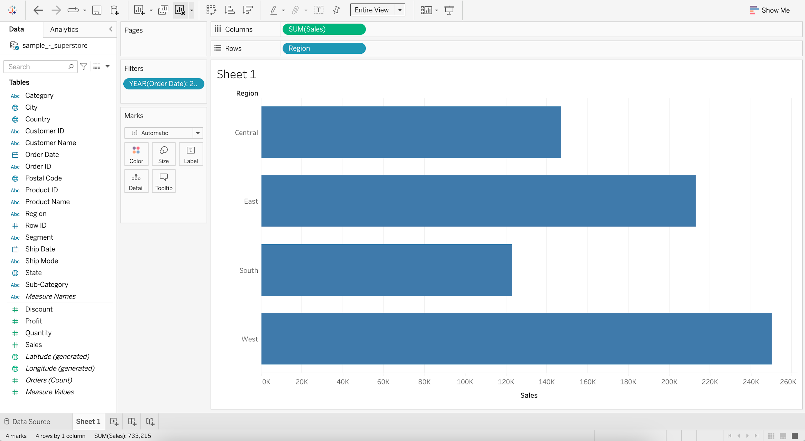

* + - Add Profit to Color
    - Add Sales to Label

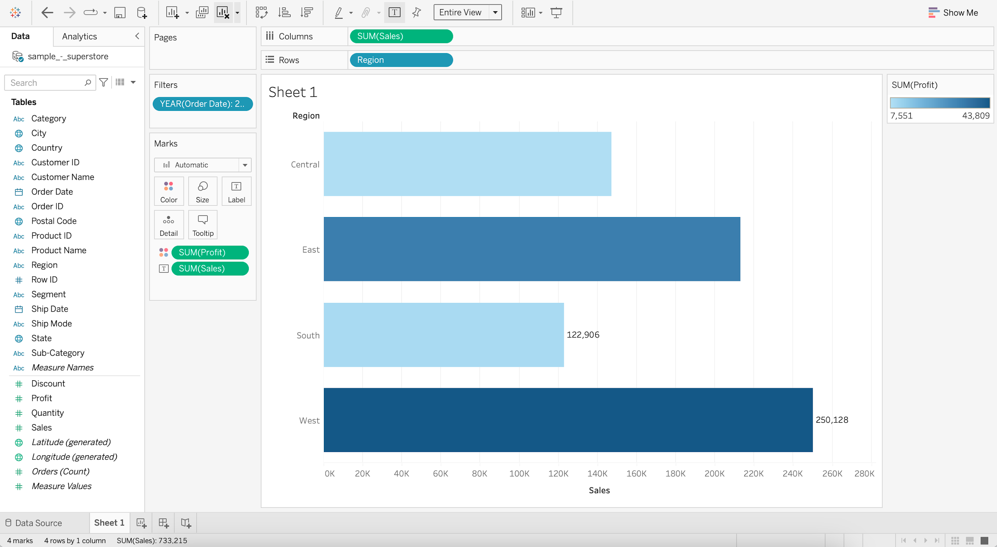

#### **Pie chart**

* It represents data as a slice of a circle with different sizes and colors.
  + **Business problem 6** : Show relative percentage of sales and profit by region for the year 2017.
    - Drag Sales to the Sheet
    - Change Marks from Automatic to Pie
    - Add Region to Color
    - Add Region to Label
    - Switch to Entire View

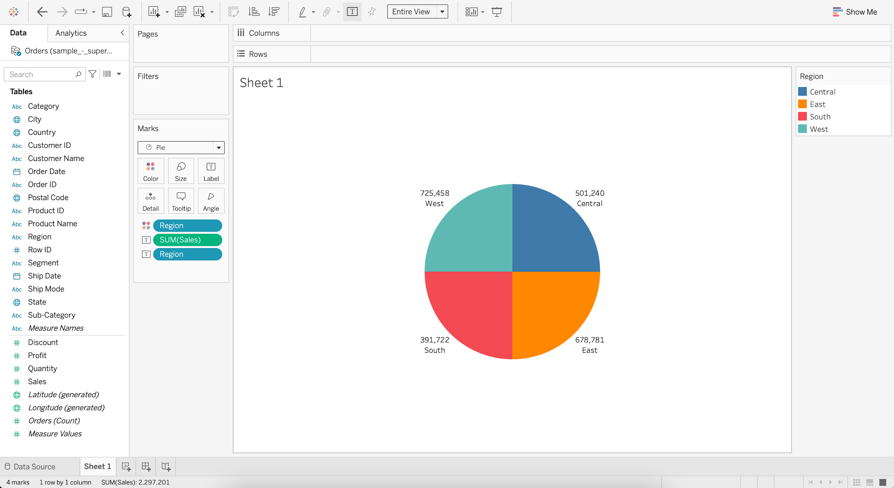

* + - For SUM(Sales), go to Quick Table Calculation
    - Select Percent of Total

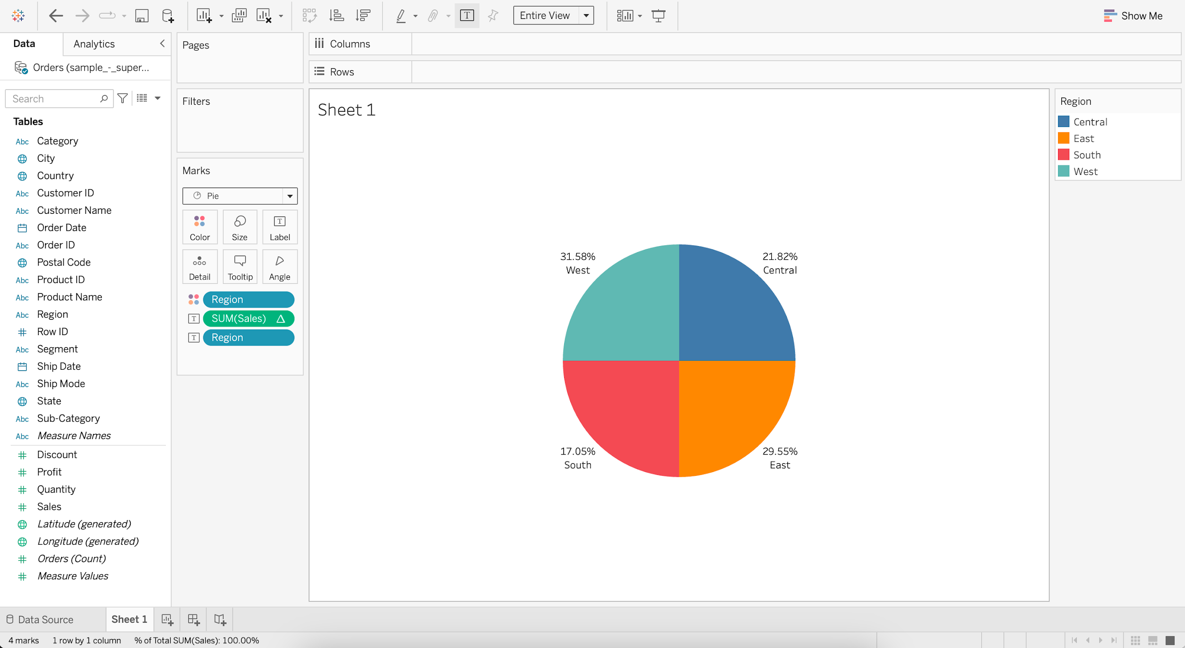

* + - Put Order Date into Filters
    - Select Years and press next
    - Select 2017 and press OK
    - Add Profit to Color
    - Add Profit to Label
    - For SUM(Profit), go to Quick Table Calculation
    - Select Percent of Total

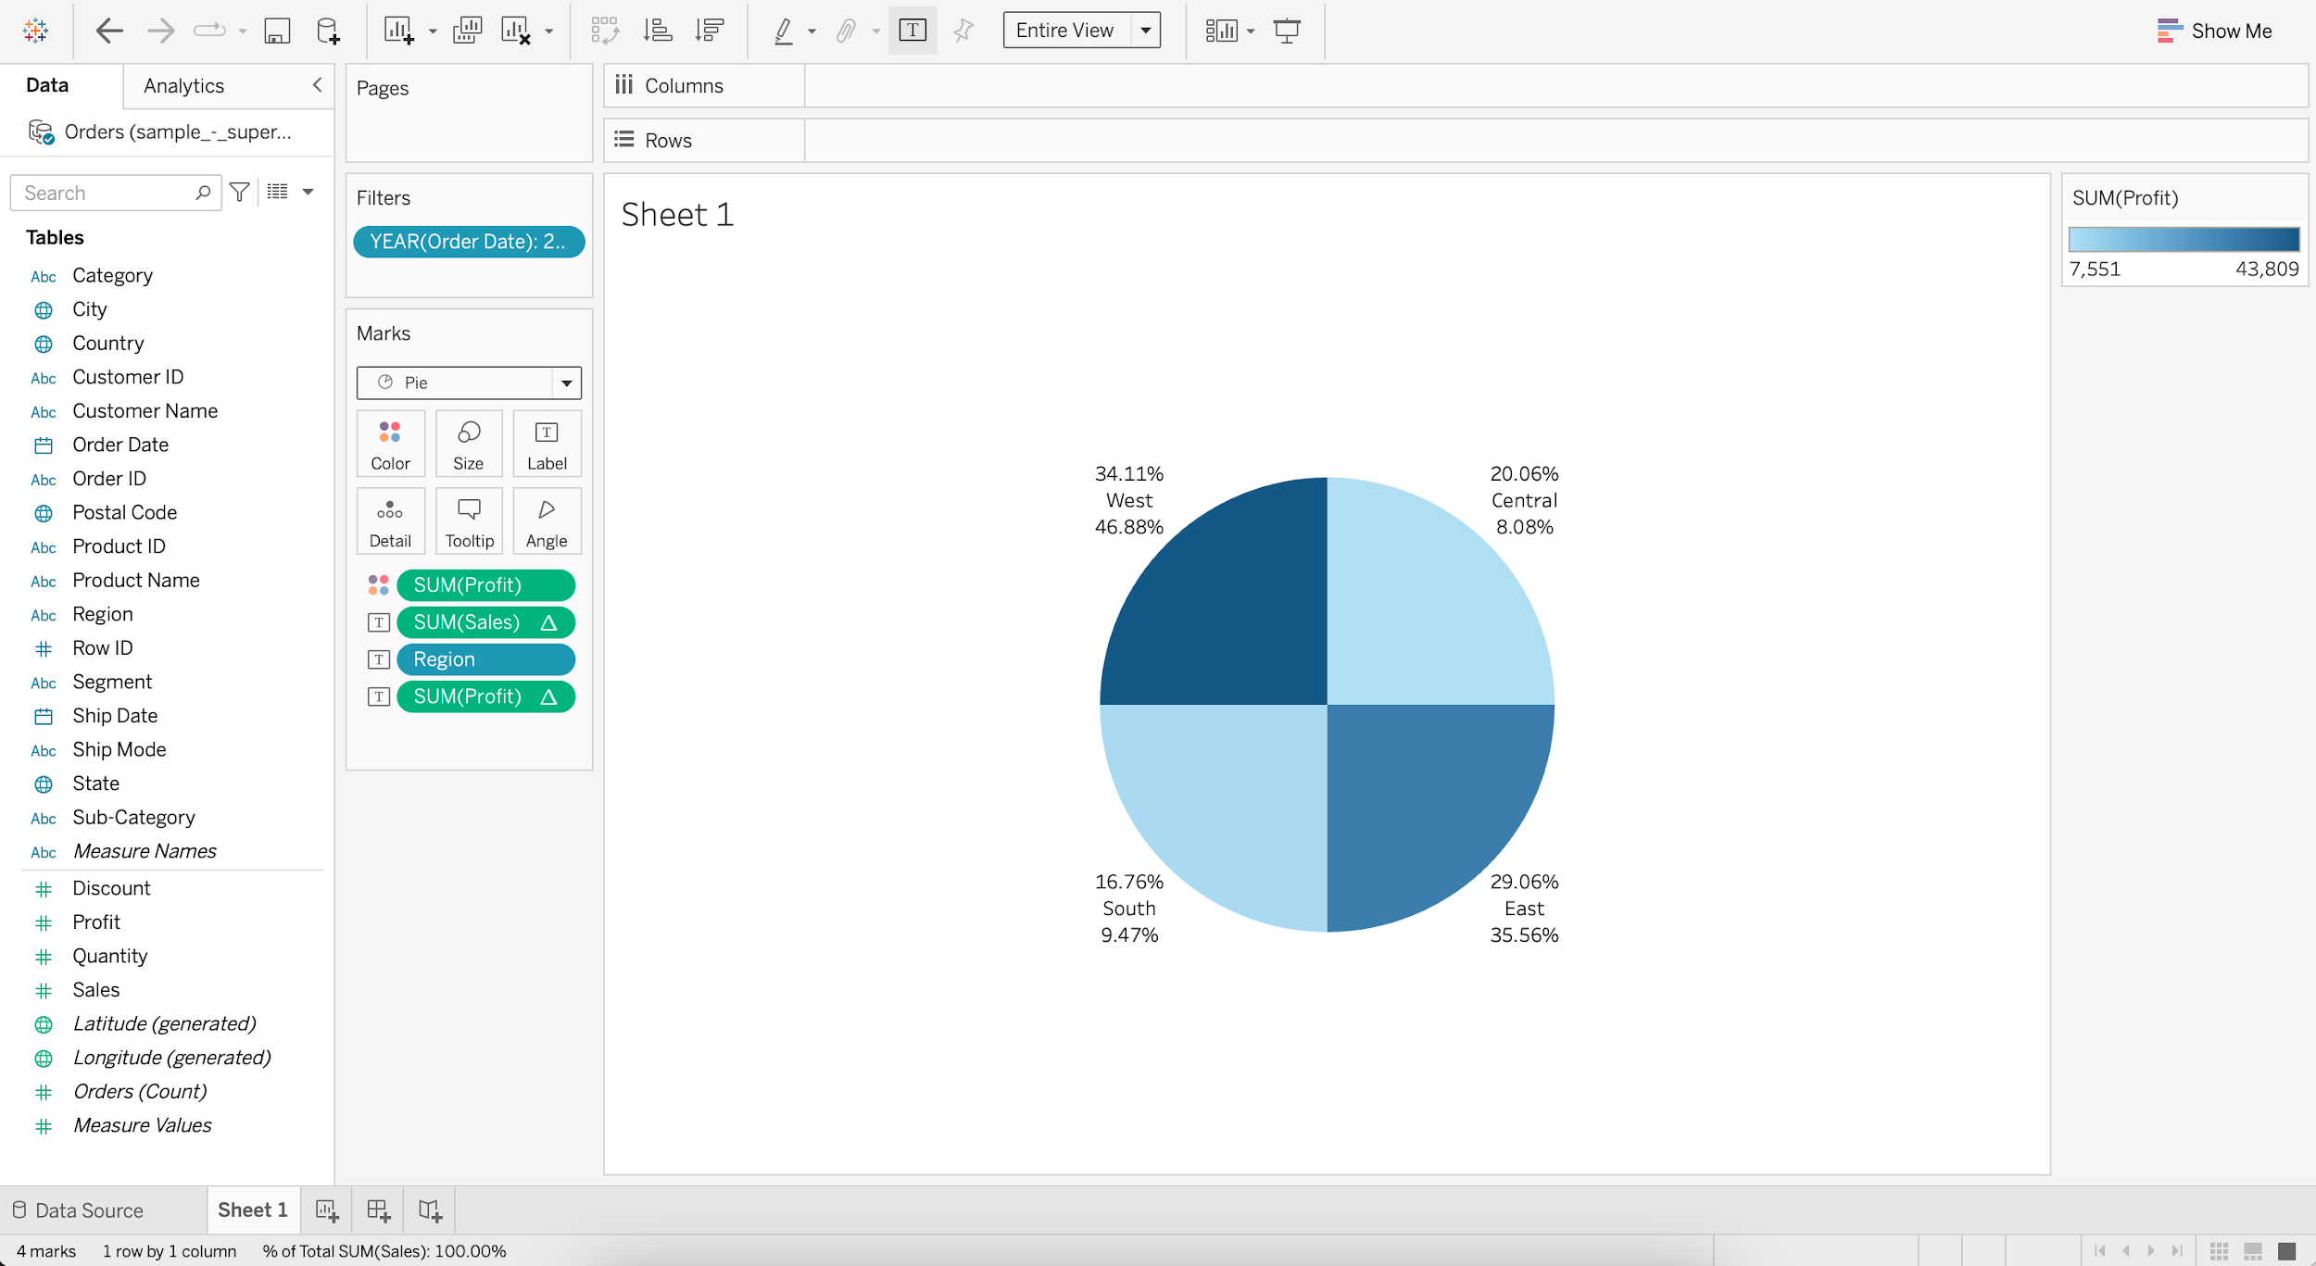

* + Annotating the Pie chart
    - Go to Label and edit the Text
    - Enter
      * For < Region > region,
      * the Total Sales is <% of Total SUM(Sales)> and
      * the Total Profit is <% of Total SUM(Profit)>

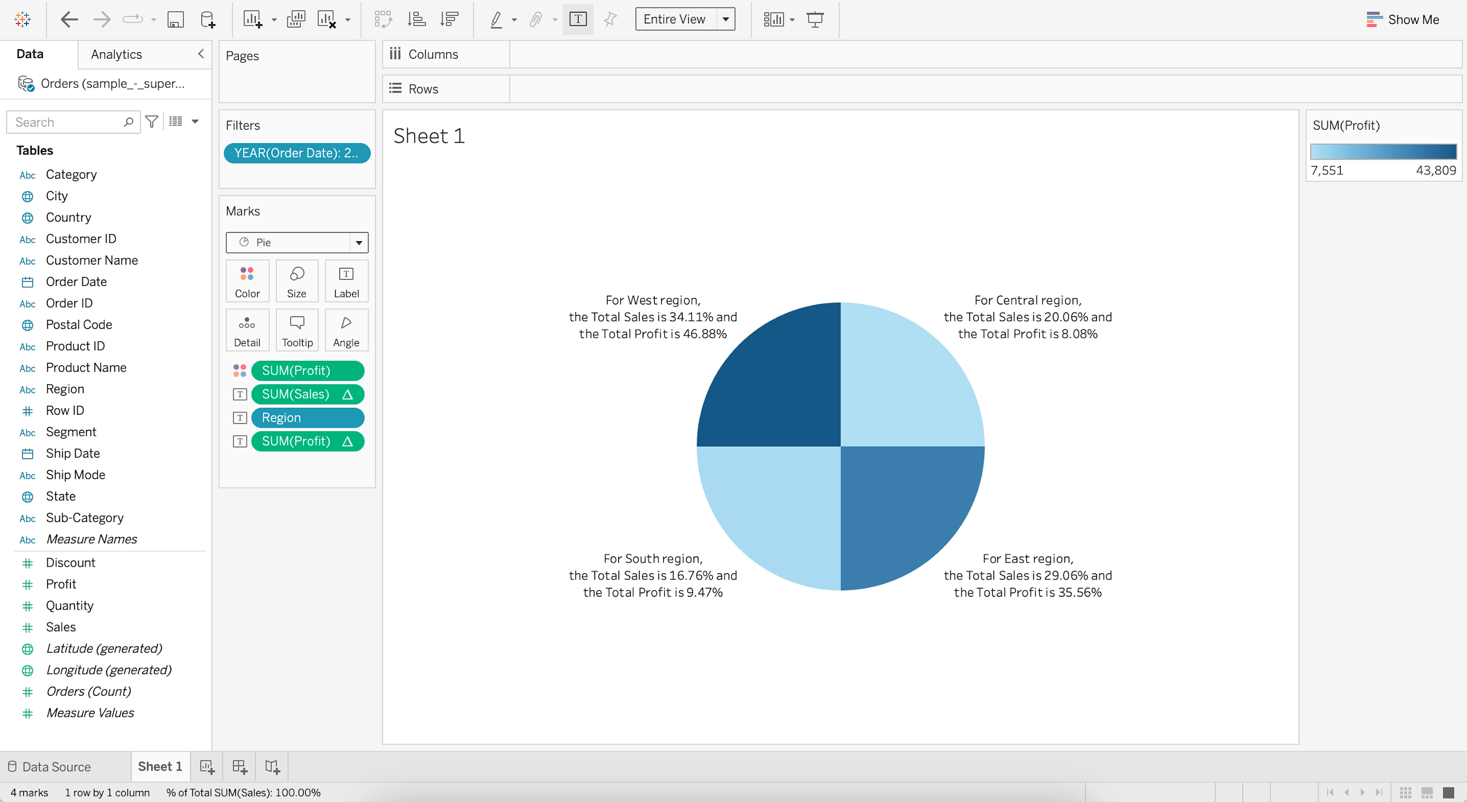

**Histogram**

* It is a chart that displays the shape of a distribution. A histogram looks like a bar chart but groups values for a continuous measure into ranges, or bins.
  + **Business problem 7**: Find sales by region based on the number of quantity sold (Bins).
    - For Quantity, go to Create and choose Bins
    - Change the Size of bins to 1.5
    - Drag Quantity (bin) to Columns
    - Drag Quantity to Rows
    - Set Quantity (bin) to Continuous

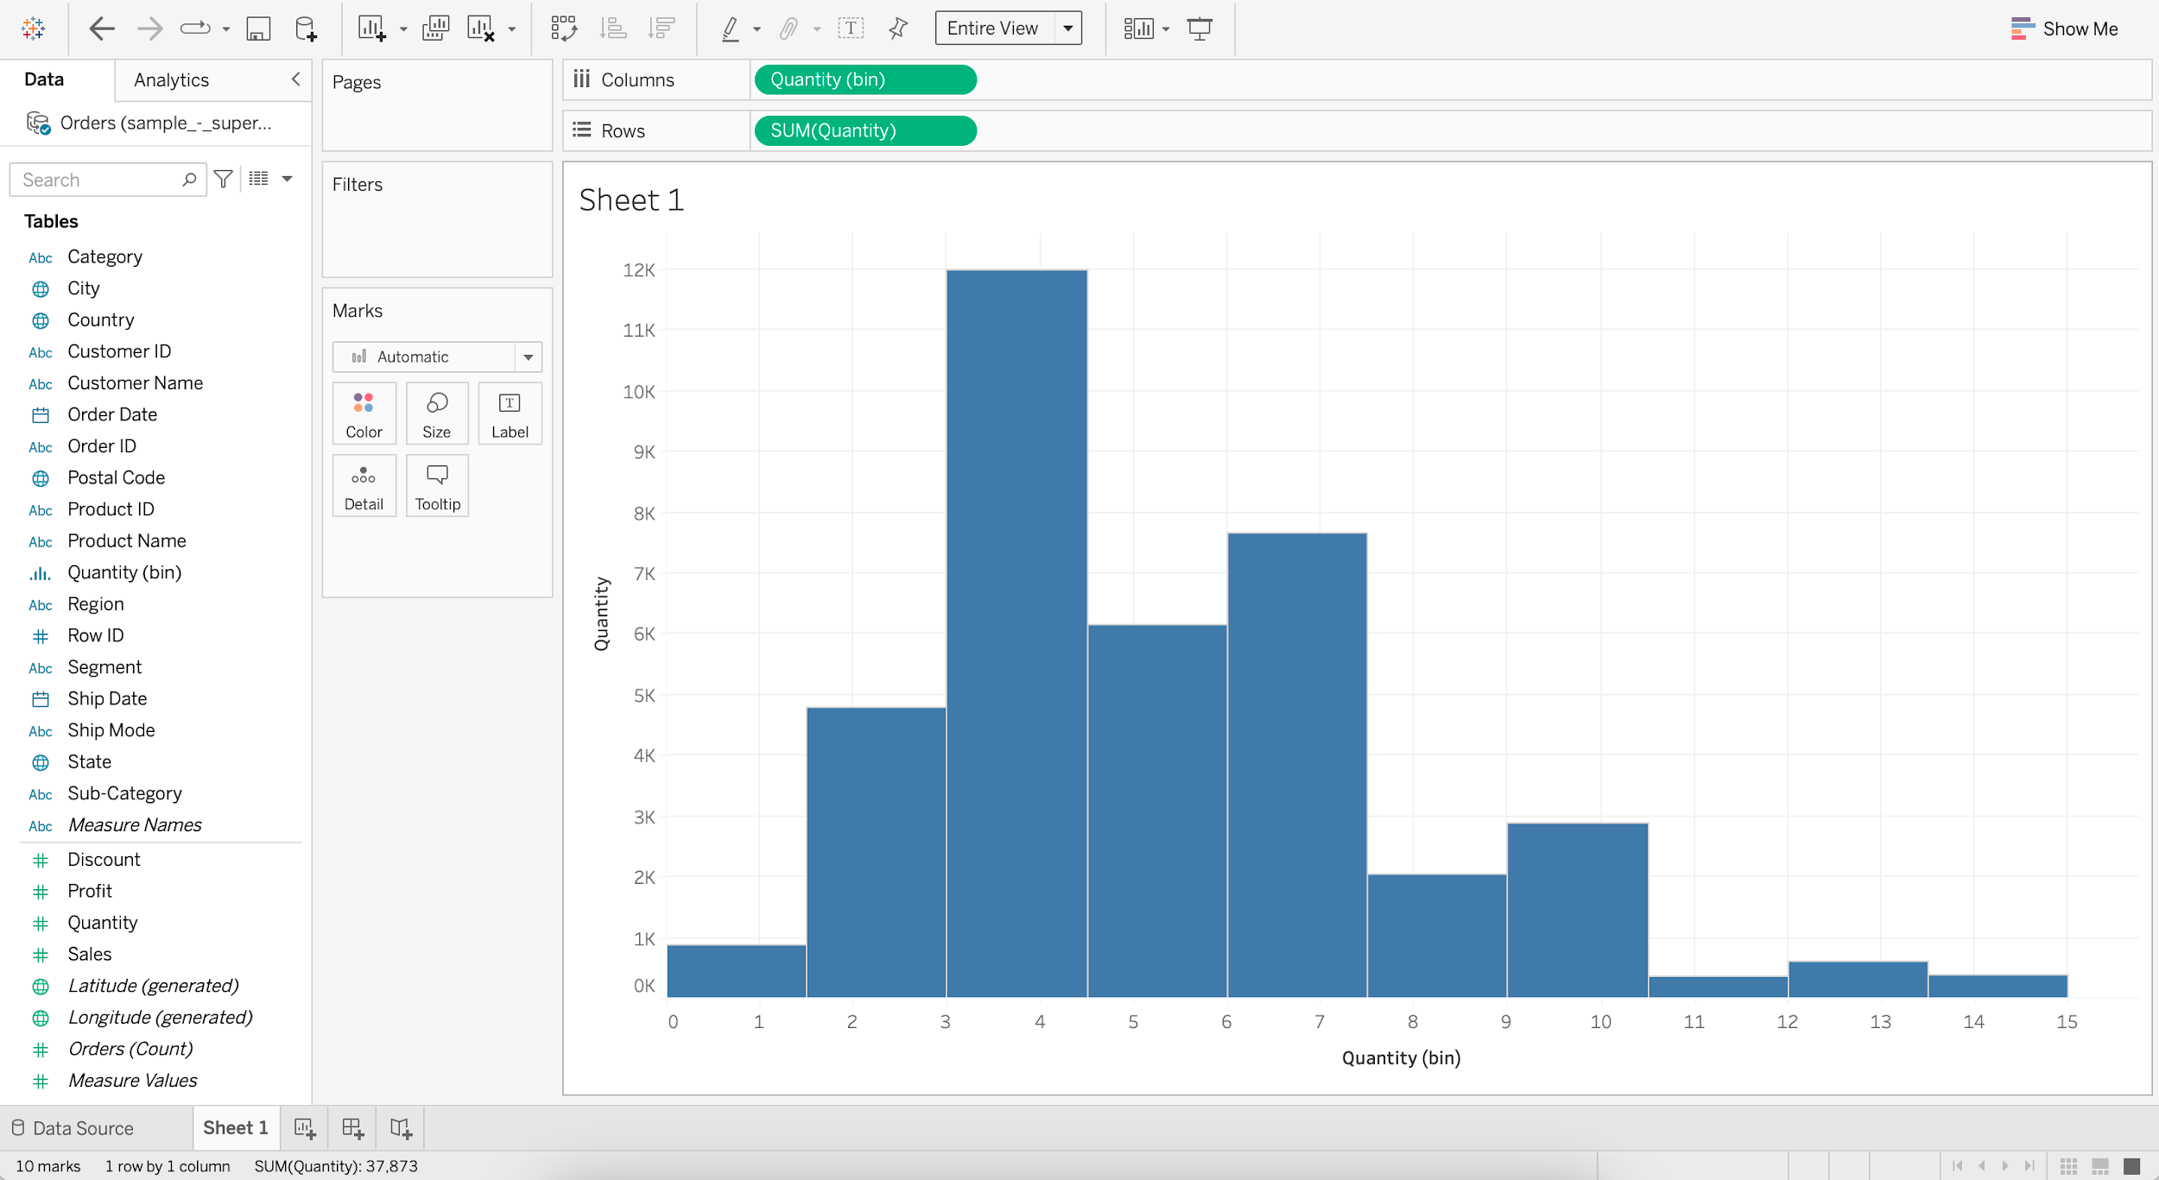

* + - Add Region to Color
    - Add Sales to Label

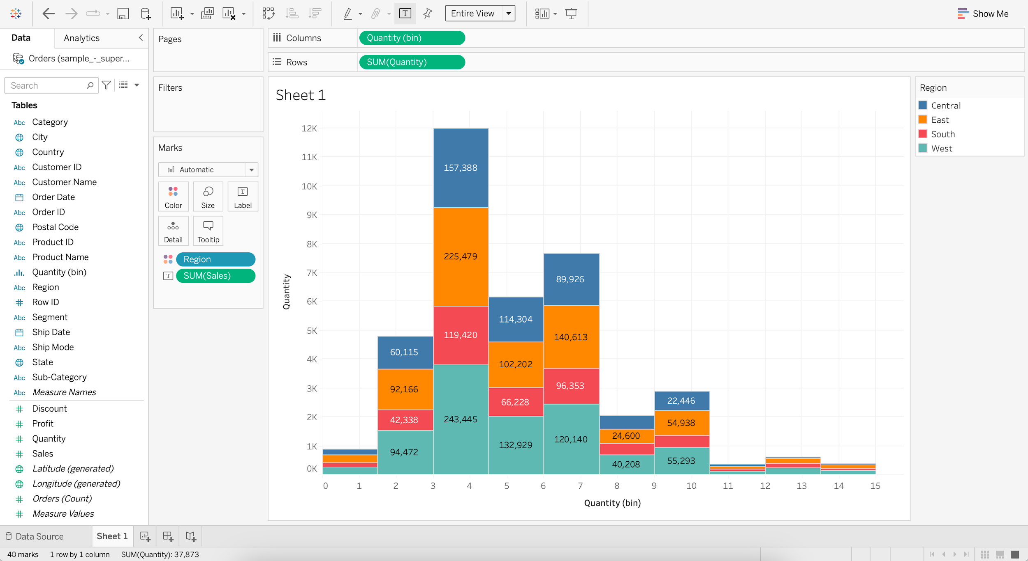

## **Cleaning and Formatting data for analysis**

#### Dataset : World_Bank_CO2.xlsx [Use CO2 (kt) RAW DATA Table]

#### Dataset url : [link](https://docs.google.com/spreadsheets/d/1PUpy6uhtn15n18f7oS9Y1Iy-VoWtEzba/edit?usp=share_link&ouid=100659516601446935794&rtpof=true&sd=true)

* **Business problem 8:**
  + Find the CO2 emissions per country per year for those countries which have CO2 emissions above 2000 kt.
    - Load the World_Bank_CO2.xlsx dataset
    - Drag the CO2 (kt) RAW DATA table
    - Check the Use Data Interpreter option

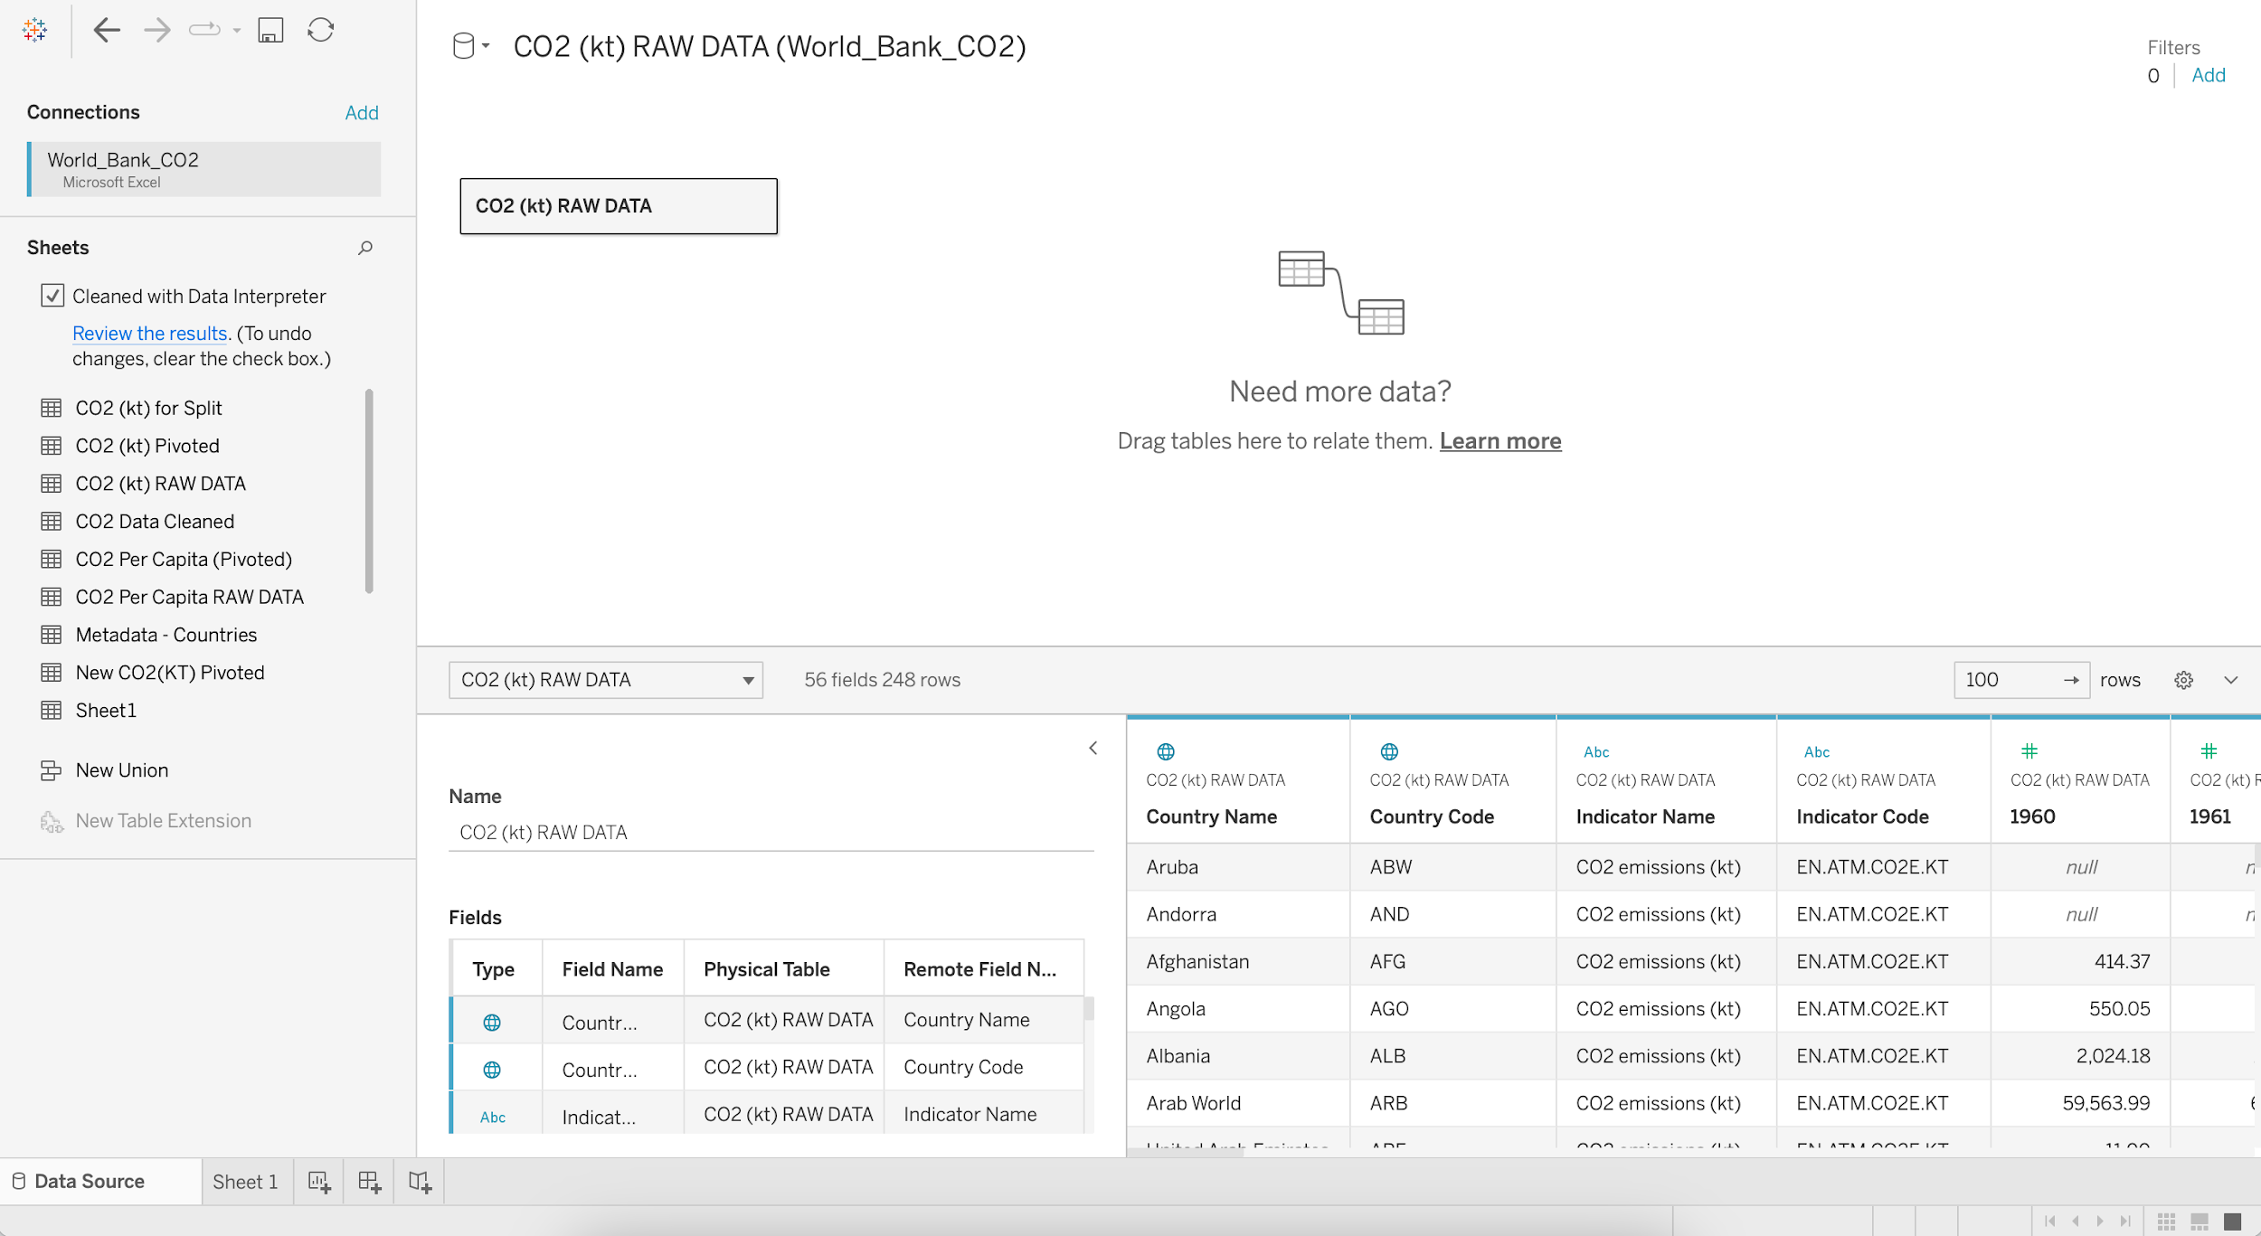

* + - Select the columns 1960 to 2011 and Pivot

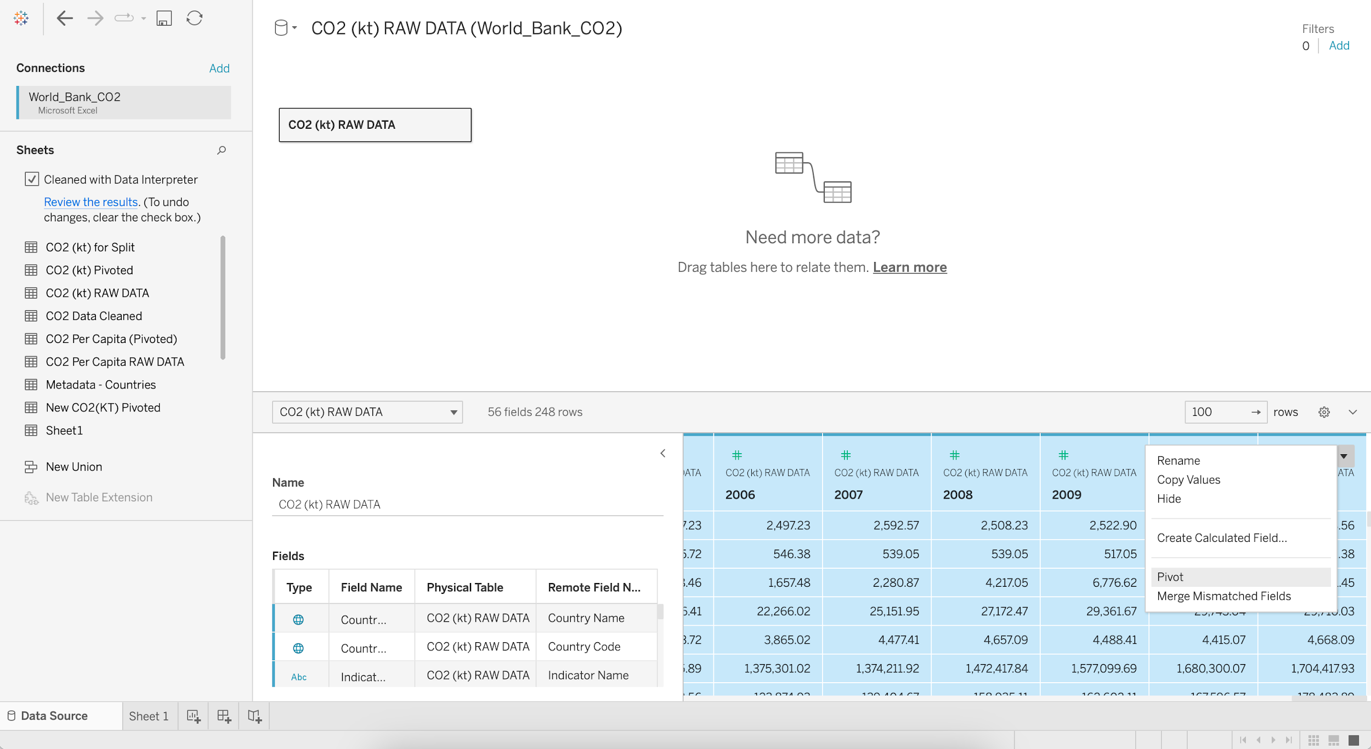

* + - Rename the PIVOT FIELD NAMES column as Year
    - Rename the PIVOT FIELD VALUES column as CO2 (kt)

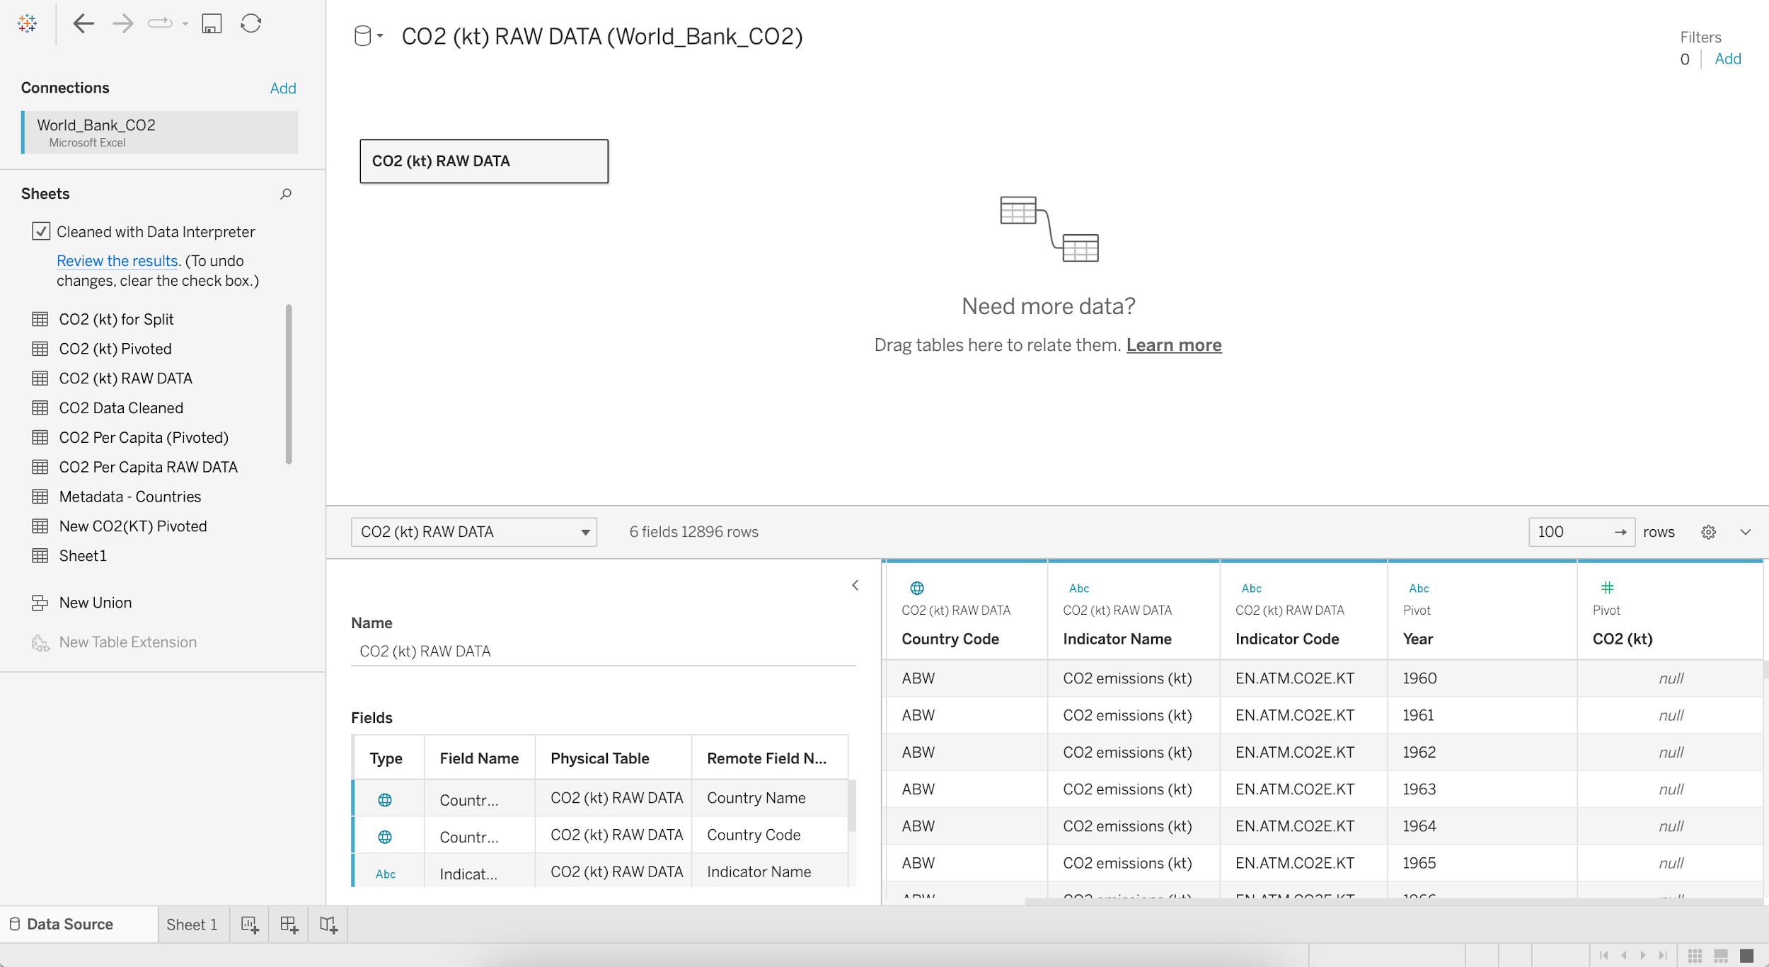

* + - Go the Filters in the upper right corner and click Add
    - Again click Add and Select a field as CO2 (kt)
    - Select the minimum Range of values as 2000

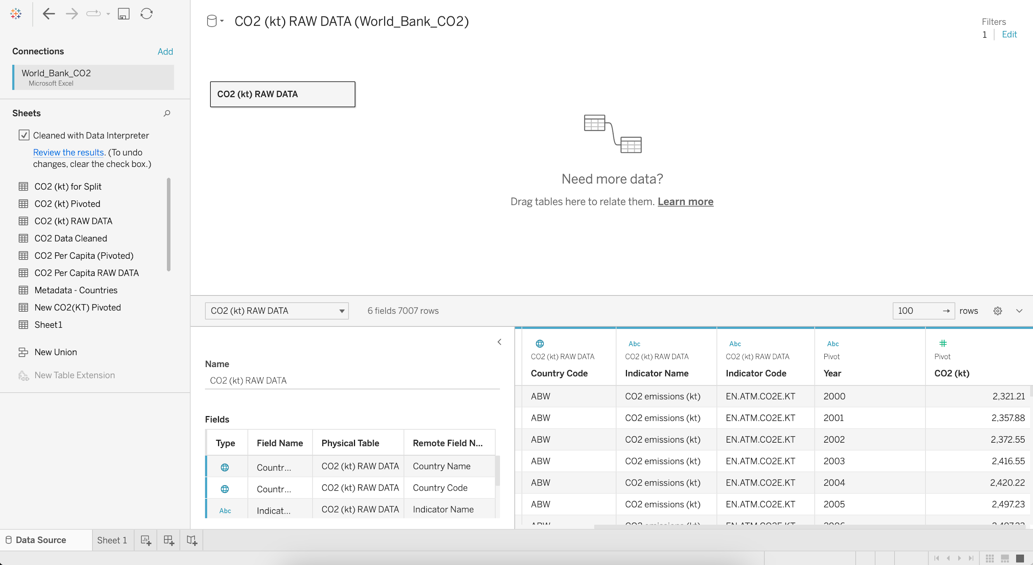

## **Data Interpreter**

* When you track data in Excel spreadsheets, you create them with the human interface in mind.
* To make your spreadsheets easy to read, you might include things like titles, stacked headers, notes, maybe empty rows and columns to add white space, and you probably have multiple tabs of data too.
* When you want to analyze this data in Tableau, these aesthetically pleasing attributes make it very difficult for Tableau to interpret your data.

That’s where a Data Interpreter can help.

**What does a Data Interpreter do?**

* It can give you a head start when cleaning your data by detecting things like titles, notes, footers, empty cells, etc.
* And bypassing them to identify the actual fields and values in your data set.

**Note:**

* Data Interpreter is only available for Microsoft Excel, Text (.csv) files, PDF files and Google Sheets.
* For Excel, your data must be in the .xls or .xlsx format.

For more information: <https://help.tableau.com/current/pro/desktop/en-us/data_interpreter.htm>

## Pivoting Data

* Sometimes analyzing data from a spreadsheet or crosstab format can be difficult in Tableau.
* Tableau prefers data to be “tall” instead of “wide”, which means that you often have to pivot your data from columns to rows so that Tableau can evaluate it properly.

**Note:** Pivoting from rows to columns is not available in Tableau Public.

For more information: <https://help.tableau.com/current/prep/en-us/prep_pivot.htm>

## **Data Source Filter**

* The data source filter is used to filter the data in data source proportion.
* It restricts the files present in the dataset.
* A data source filter works on both Live connection and Extract connection.

### **Filter shelf**

We can use a filter shelf to filter data in the view.

#### Dataset : World_Bank_CO2.xlsx [Use CO2 (kt) RAW DATA Table]

* **Business problem 9**:
  + Find the CO2 emissions per country per year where CO2 emission >= 2K kt
    - Drag Year to Columns
    - Drag CO2 (kt) to Rows
    - Change Marks from Automatic to Line
    - Add Country Name to Color
    - Edit Title as “CO2 emissions per country per year where CO2 emission >= 2K kt”

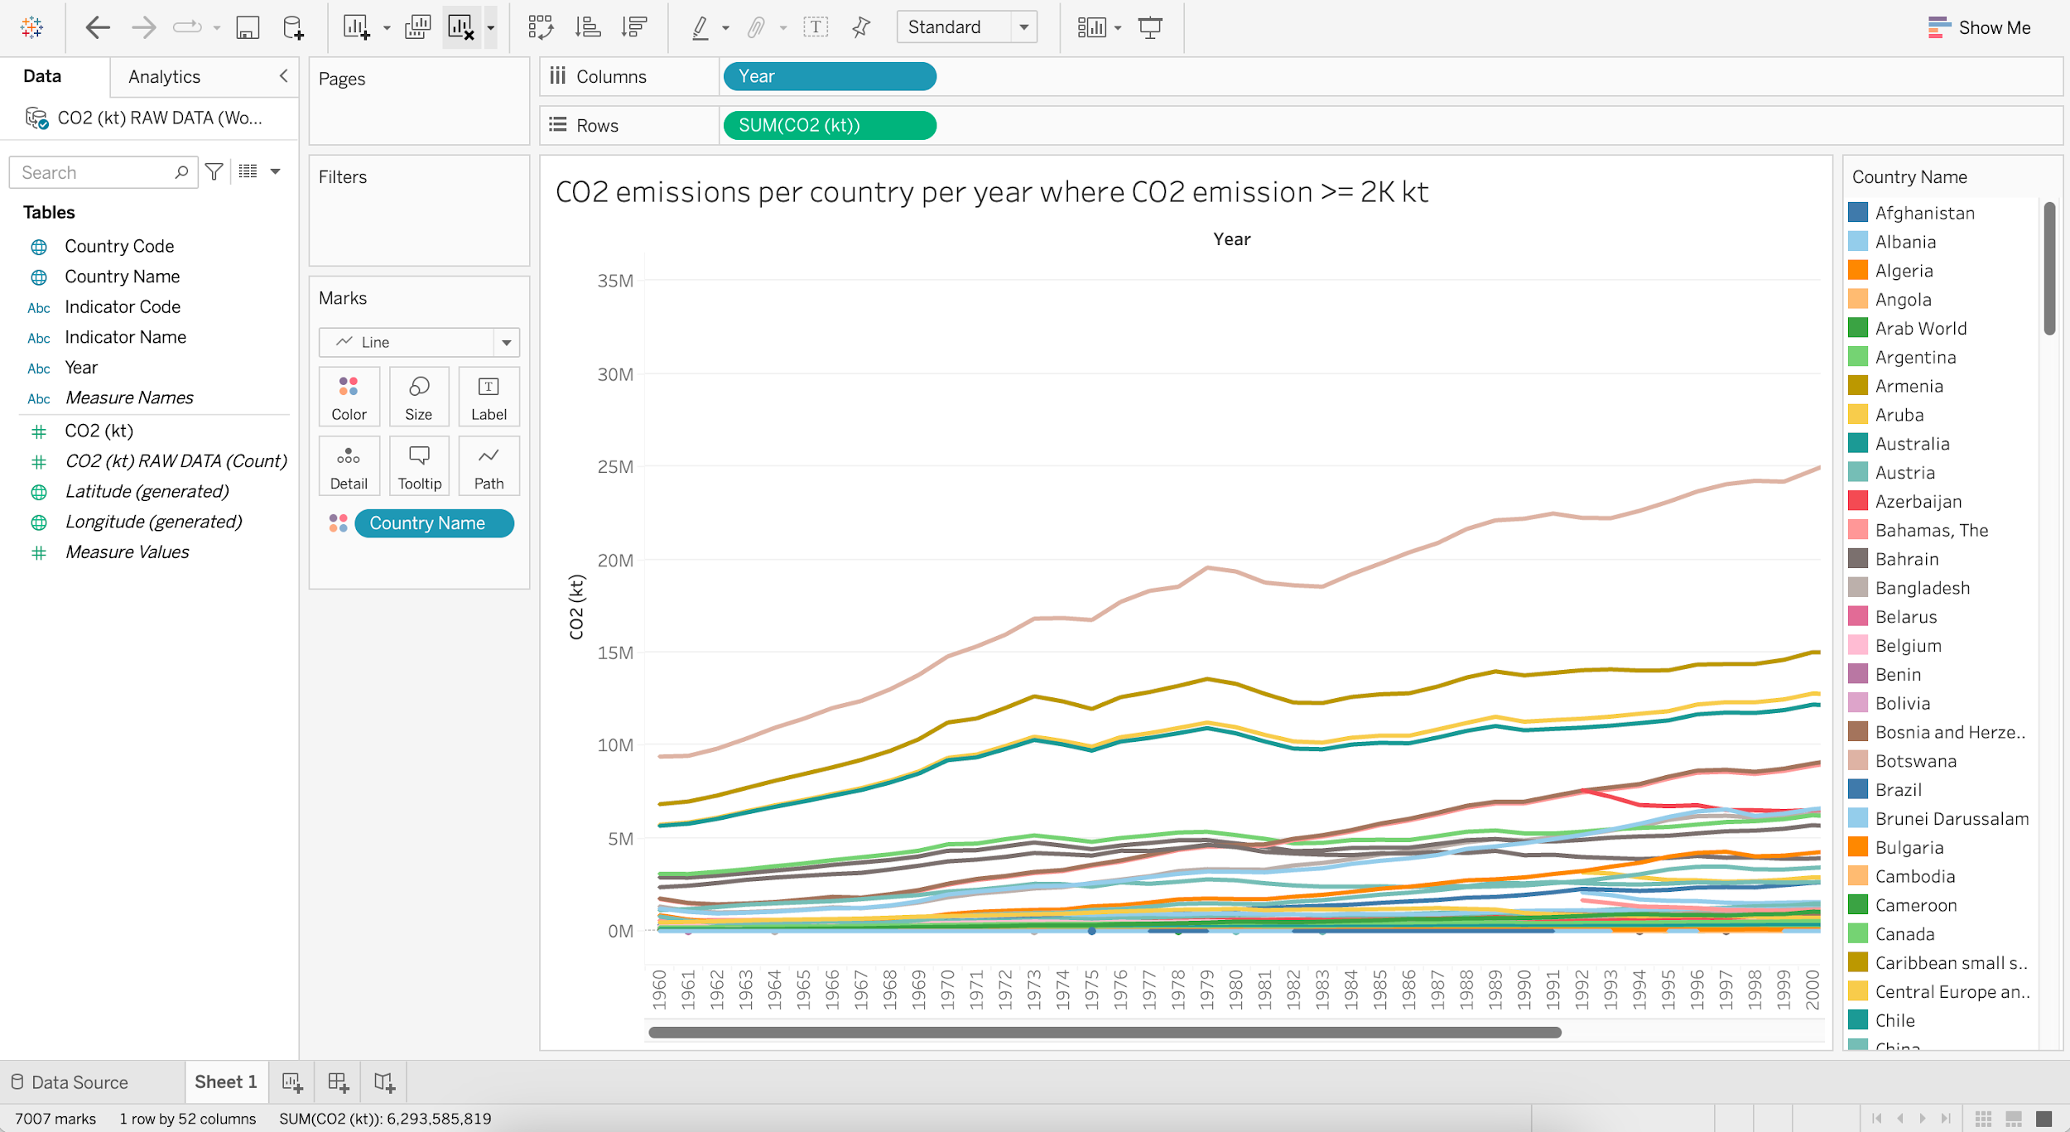

* + Find the per year CO2 emissions of top 10 countries where CO2 emissions >= 2K kt.
    - Put Country Name into Filters
    - Go to Top and Select Top 10 Fields by Sum of CO2 (kt)
    - Edit Title as “Per year CO2 emissions of top 10 countries where CO2 emissions >= 2K kt”

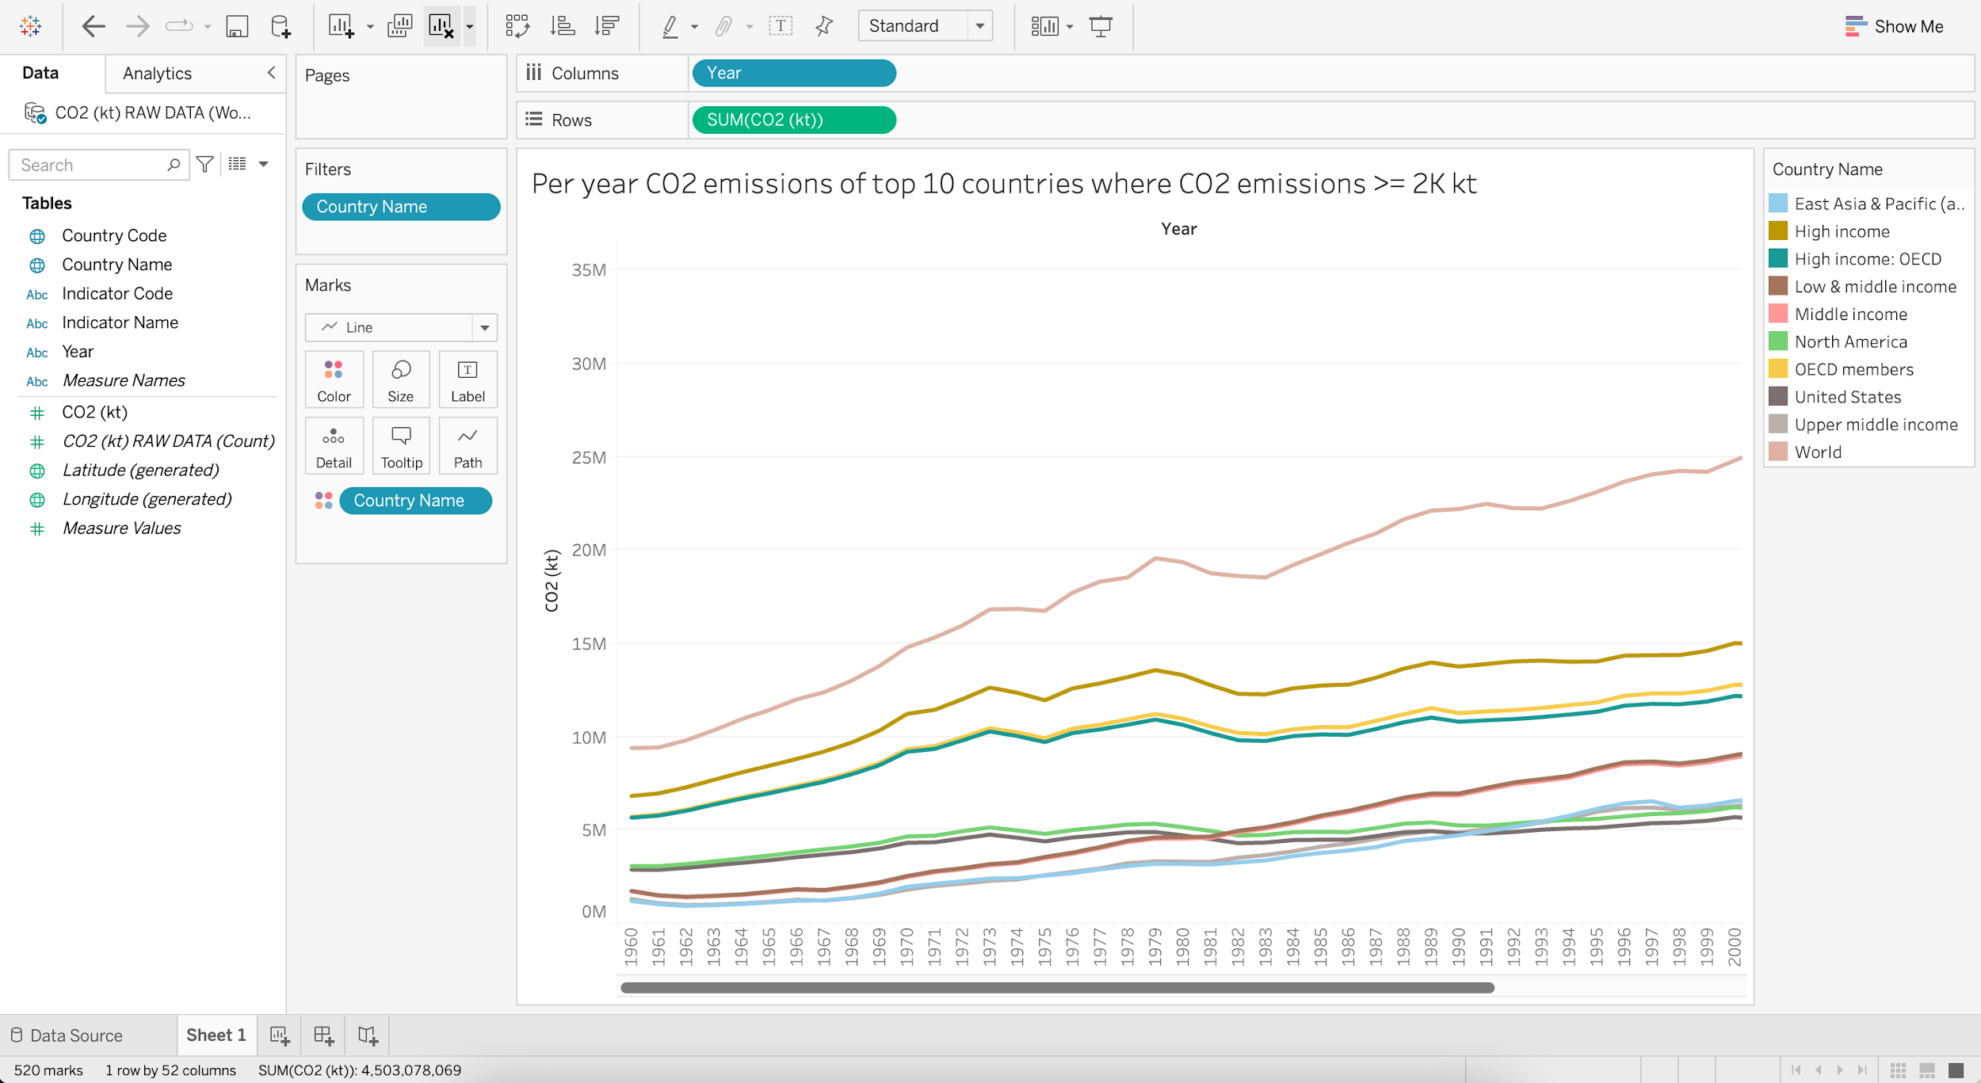

## **Creating & Uploading Dashboard**

* Consider this as an extra activity.
* Create and Upload a basic dashboard based on the worksheets created above (Business problem 1 to 7).